Managing
agile projects
with
PRINCE2 Agile®

Foundation
Workbook

2020
PRINCE2 and PRINCE2 Agile are registered trade marks of AXELOS Limited,
used under permission of AXELOS Limited. All rights reserved.

Copyright © 2006-2022 Aspire Australasia Pty Ltd unless otherwise stated. All rights reserved.

Geoff Rankins asserts his moral right to be acknowledged as author of this work.

This publication is sold subject to the condition that it, or any part of it, shall not by way of trade or otherwise, be sold, lent, re-sold, displayed, advertised or otherwise circulated, without the publisher’s prior written consent, in any form of binding, cover or title other than that in which it is published and without a similar condition including this condition being imposed on the subsequent purchaser(s).
This publication is sold subject to the condition that it, or any part of it, shall not be reproduced, stored or transmitted, without the publisher’s prior written consent, and without a similar condition including this condition being imposed on the subsequent purchaser(s).

Published under license by:

Inspiring Projects
www.InspiringProjects.com.au
training@InspiringProjects.com.au

Material derived from the PRINCE2 Agile manual is flagged with the statement:
Based on AXELOS PRINCE2 Agile material. Reproduced under licence from AXELOS Limited. All rights reserved

Welcome

Welcome to our PRINCE2 Agile Foundation Course. This is one element of our suite of project management training courses, designed to assist both individuals and organisations.

PRINCE2 Agile is a blended approach combining PRINCE2 and agile concepts that gives project managers the skills and knowledge to benefit from agile delivery, whilst maintaining purposeful levels of control with PRINCE2. PRINCE2 Agile takes PRINCE2 and provides additional explicit guidance on:
- Frameworks (e.g. Lean Startup, Kanban, Scrum)
- Behaviours (e.g. self-organising teams)
- Focus areas (e.g. Agilometer, agile contracts)
- Techniques (e.g. user stories, timeboxing)
- Concepts (e.g. not delivering everything)

For the past twenty years, our instructors have been successfully training participants to understand and use the project management methods as well as pass the related certification examinations.

Inspiring Projects is a privately owned provider of project management and project related services and training. The company provides consultancy services to clients including consulting firms, large corporates, SMEs, Universities, multinationals, and State and Federal Government Departments and agencies. We have provided our services across Australasia, Asia, Africa and Europe.

The mission of the company is to support organisations undertaking projects, changing their environment or introducing standard project and programme management methods, through the provision of high quality consultancy and management support. This support includes professional programme and project management services, training, certification, consultancy and associated services to assist clients to develop their expertise in the efficient organisation and profitable delivery of programmes and projects. Our consultants have developed project management systems built around PRINCE2, and we have provided Executive Briefings, coaching, mentoring and interim staffing support to ensure our clients maximise the benefits from their investment in PRINCE2.

We are pleased to be able to assist in your training and trust that you will find the course beneficial and interesting.

Geoff Rankins
Lead Trainer
Inspiring Projects

This page intentionally left blank

Table of Contents
1. Course Schedule 6
2. Introducing ‘agile’ 7
3. Introducing PRINCE2 13
4. Agile ways of working 18
5. Blending PRINCE2 and Agile 29
6. Tailoring PRINCE2 for agile 36
7. PRINCE2 Agile’s Focus Areas 47
8. Answers to Review Questions 53

Course Schedule
Day 1 | Session
08:45 | 1  2  3 | Introductions  Introducing ‘agile’  Morning break  Introducing PRINCE2
12:30 |  | Lunch (45 mins)
13:15 | 4  5 | Agile ways of working  Afternoon break  Blending PRINCE2 and agile
16:30 |  | CLOSE
Homework |  | Read Appendix A – Product Description outlines  Read Appendix B – Role Descriptions
Day 2 | Session
08:45 | 6  7  8 | Review of yesterday & homework  Tailoring - PRINCE2 Principles and agile behaviours  Morning break  Tailoring - PRINCE2 themes  Tailoring – PRINCE2 processes and documents
12:30 |  | Lunch (45 mins)
13:15 | 9  10 | PRINCE2 Agile Focus Areas  Afternoon break  Exam Technique  Course evaluation and closure
16:30 |  | CLOSE

Introducing ‘agile’

Slides
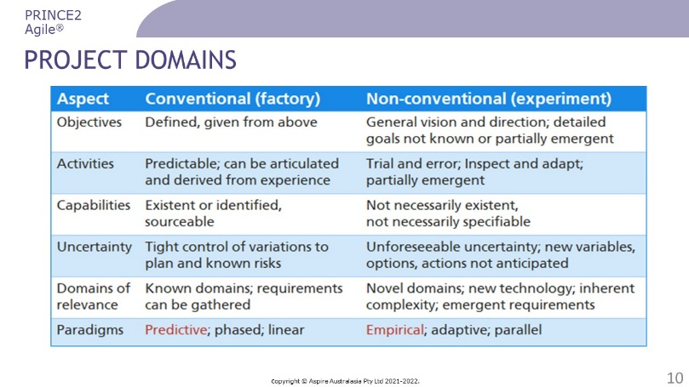 | ………………….………………………….………………  ……………………….……………….……………………  ………………………….……….…………………………  ………………….………….………………………………  …………………………………..…………………………  …………………………………..…………………………
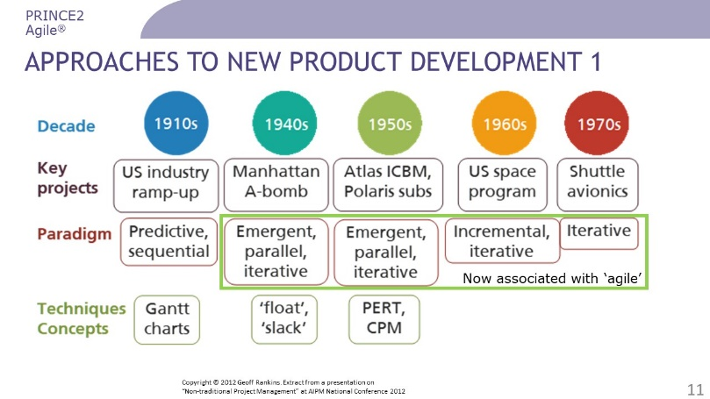 | ………………….………………………….………………  ……………………….……………….……………………  ………………………….……….…………………………  ………………….………….………………………………  …………………………………..…………………………  …………………………………..…………………………
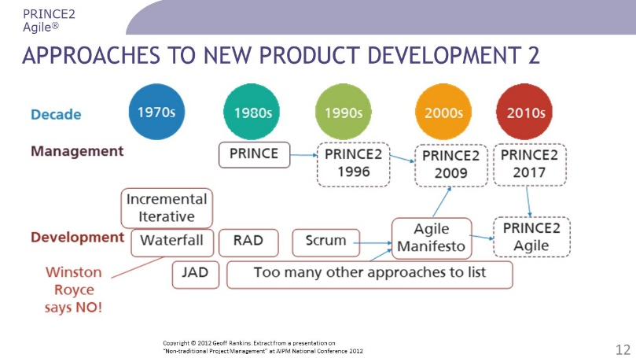 | ………………….………………………….………………  ……………………….……………….……………………  ………………………….……….…………………………  ………………….………….………………………………  …………………………………..…………………………  …………………………………..…………………………
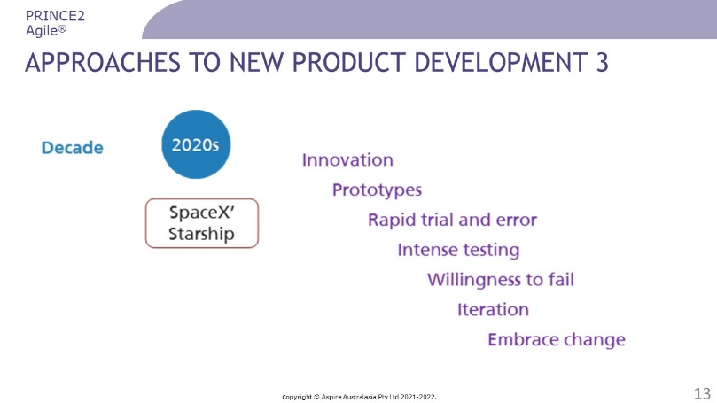 | ………………….………………………….………………  ……………………….……………….……………………  ………………………….……….…………………………  ………………….………….………………………………  …………………………………..…………………………  …………………………………..……………………………………………………………..………………………………………..
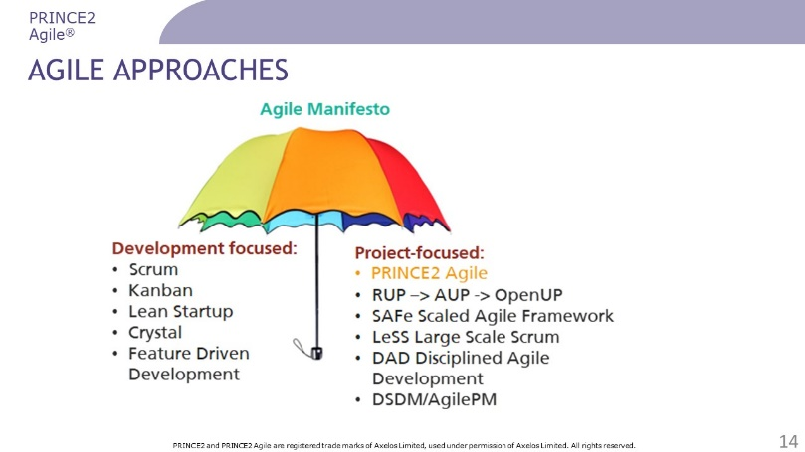 | ………………….………………………….………………  ……………………….……………….……………………  ………………………….……….…………………………  ………………….………….………………………………  …………………………………..…………………………  …………………………………..…………………………  …………………………………..………………………………………..
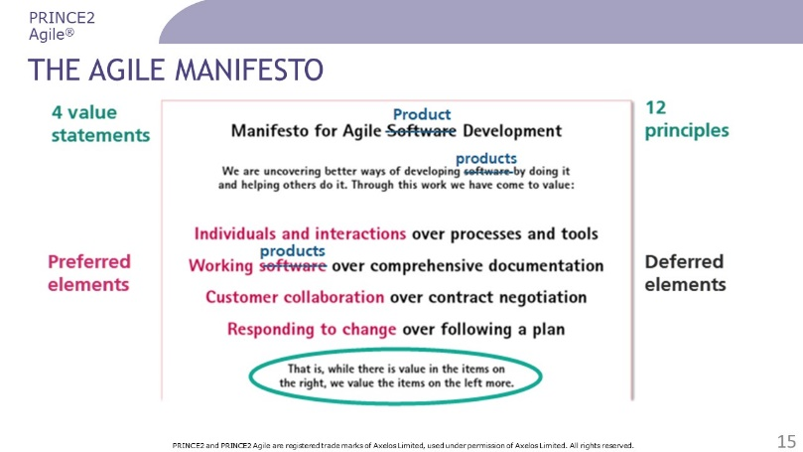 | ………………….………………………….………………  ……………………….……………….……………………  ………………………….……….…………………………  ………………….………….………………………………  …………………………………..…………………………  …………………………………..………………………………………………………..………………………………………..
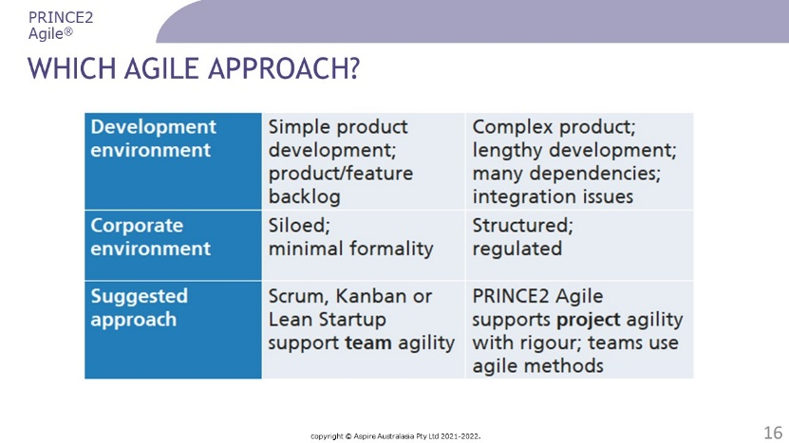 | ………………….………………………….………………  ……………………….……………….……………………  ………………………….……….…………………………  ………………….………….………………………………  …………………………………..…………………………  …………………………………..………………………………………………………..………………………………………..
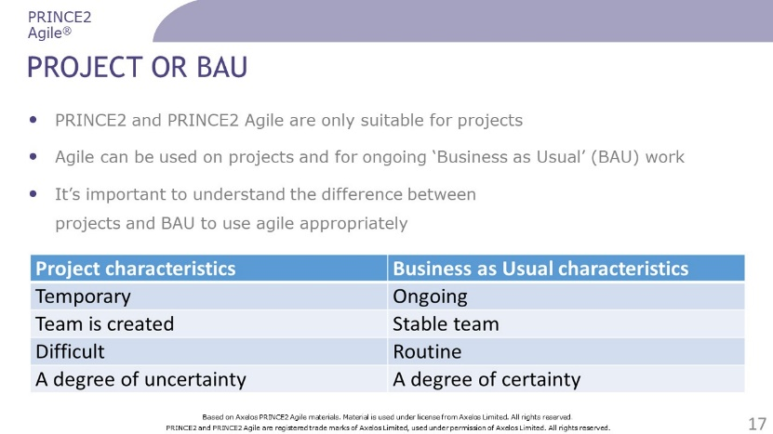 | ………………….………………………….………………  ……………………….……………….……………………  ………………………….……….…………………………  ………………….………….………………………………  …………………………………..…………………………  …………………………………..………………………………………………………..………………………………………..
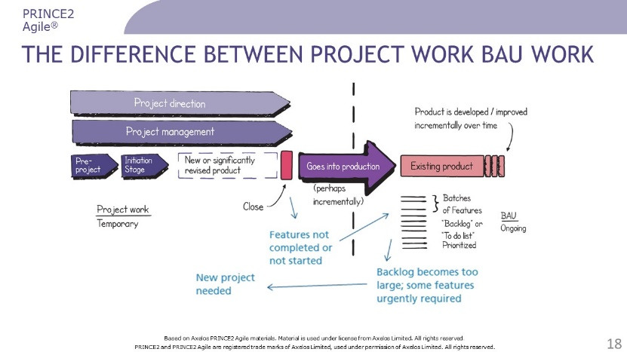 | ………………….………………………….………………  ……………………….……………….……………………  ………………………….……….…………………………  ………………….………….………………………………  …………………………………..…………………………  …………………………………..………………………………………………………..………………………………………..
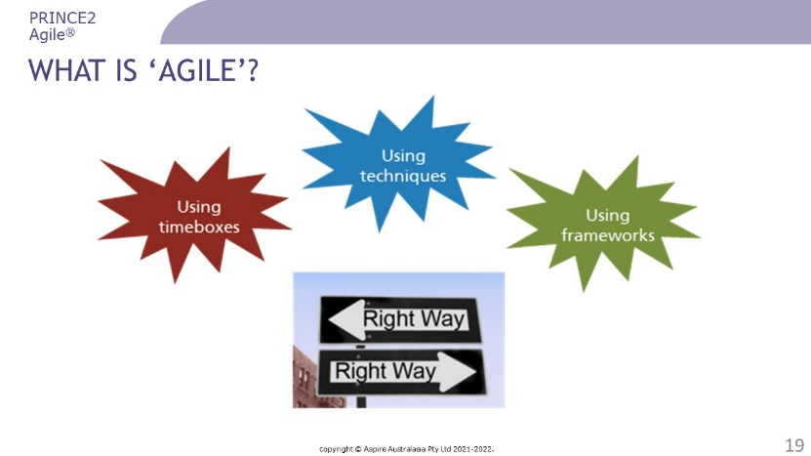 | ………………….………………………….………………  ……………………….……………….……………………  ………………………….……….…………………………  ………………….………….………………………………  …………………………………..…………………………  …………………………………..………………………………………………………..………………………………………..
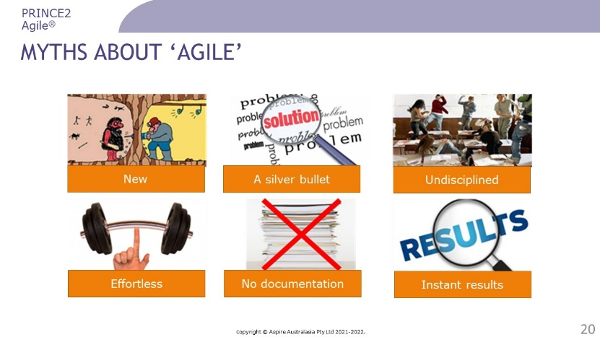 | ………………….………………………….………………  ……………………….……………….……………………  ………………………….……….…………………………  ………………….………….………………………………  …………………………………..…………………………  …………………………………..………………………………………………………..………………………………………..
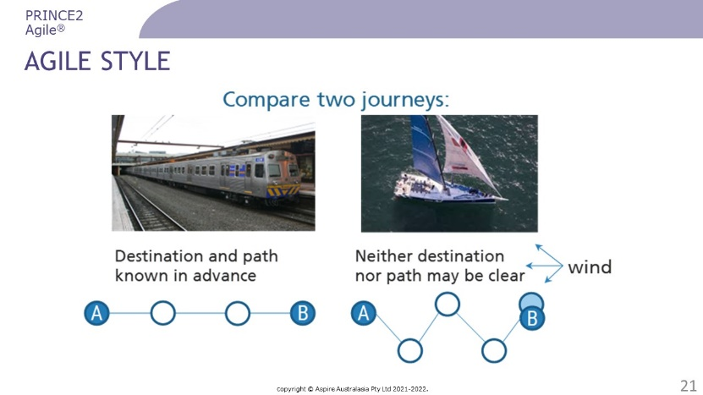 | ………………….………………………….………………  ……………………….……………….……………………  ………………………….……….…………………………  ………………….………….………………………………  …………………………………..…………………………  …………………………………..………………………………………………………..………………………………………..
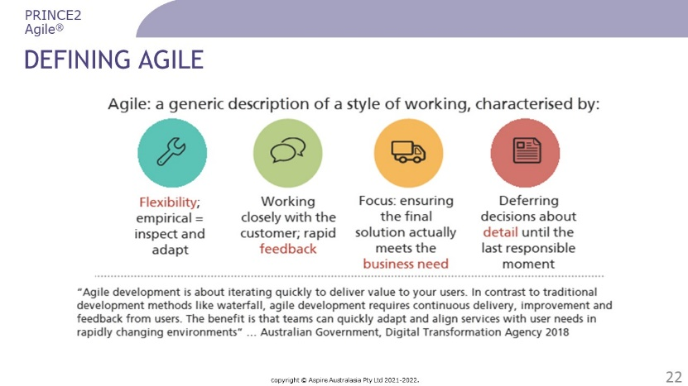 | ………………….………………………….………………  ……………………….……………….……………………  ………………………….……….…………………………  ………………….………….………………………………  …………………………………..…………………………  …………………………………..………………………………………………………..………………………………………..
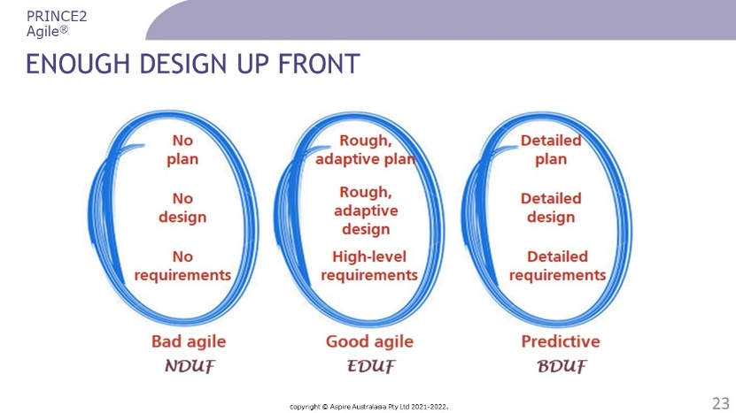 | ………………….………………………….………………  ……………………….……………….……………………  ………………………….……….…………………………  ………………….………….………………………………  …………………………………..…………………………  …………………………………..………………………………………………………..………………………………………..
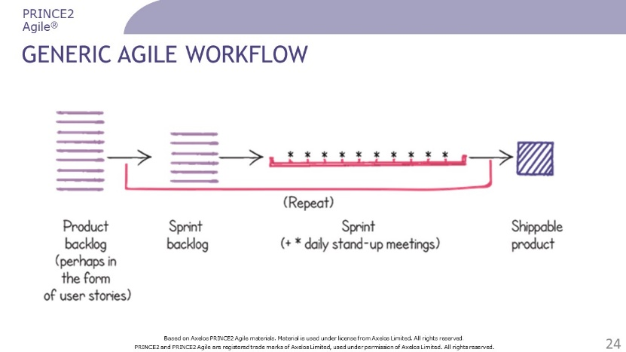 | ………………….………………………….………………  ……………………….……………….……………………  ………………………….……….…………………………  ………………….………….………………………………  …………………………………..…………………………  …………………………………..………………………………………………………..………………………………………..
Questions? | ………………….………………………….………………  ……………………….……………….……………………  ………………………….……….…………………………  ………………….………….………………………………  …………………………………..…………………………  …………………………………..………………………………………………………..………………………………………..

Introducing PRINCE2

Slides
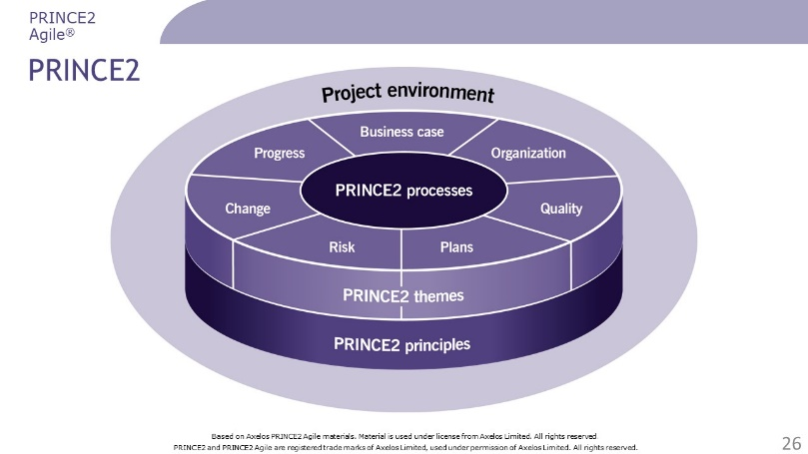 | ………………….………………………….………………  ……………………….……………….……………………  ………………………….……….…………………………  ………………….………….………………………………  …………………………………..…………………………  …………………………………..………………………………………………………..………………………………………..  …………………………………..………………………………………..
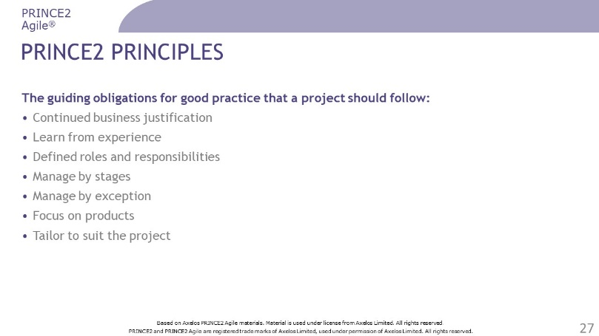 | ………………….………………………….………………  ……………………….……………….……………………  ………………………….……….…………………………  ………………….………….………………………………  …………………………………..…………………………  …………………………………..………………………………………………………..………………………………………..  …………………………………..………………………………………..
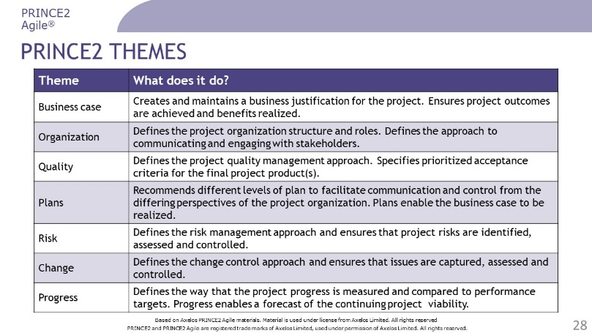 | ………………….………………………….………………  ……………………….……………….……………………  ………………………….……….…………………………  ………………….………….………………………………  …………………………………..…………………………  …………………………………..………………………………………………………..………………………………………..  …………………………………..………………………………………..
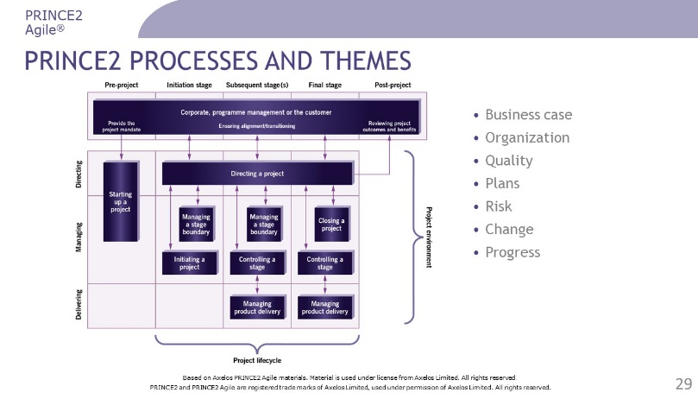 | ………………….………………………….………………  ……………………….……………….……………………  ………………………….……….…………………………  ………………….………….………………………………  …………………………………..…………………………  …………………………………..………………………………………………………..………………………………………..…………………………………..………………………………………..
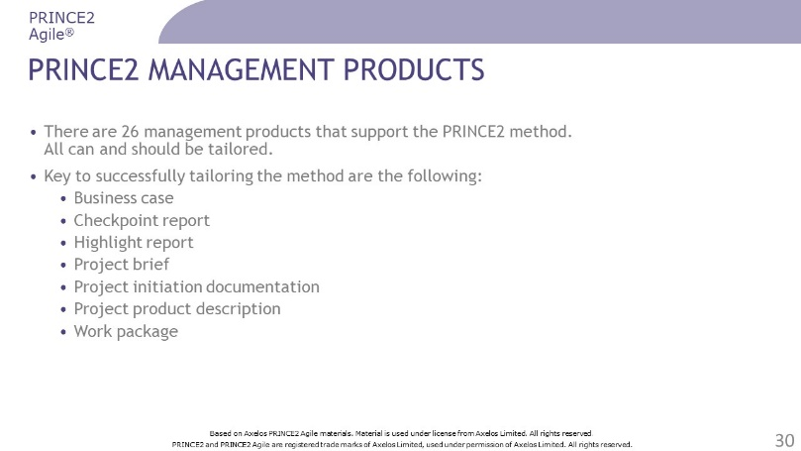 | ………………….………………………….………………  ……………………….……………….……………………  ………………………….……….…………………………  ………………….………….………………………………  …………………………………..…………………………  …………………………………..………………………………………………………..………………………………………..…………………………………..………………………………………..
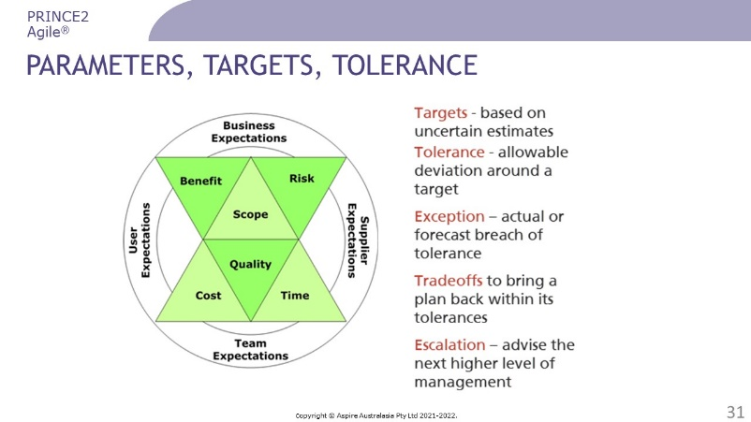 | ………………….………………………….………………  ……………………….……………….……………………  ………………………….……….…………………………  ………………….………….………………………………  …………………………………..…………………………  …………………………………..………………………………………………………..………………………………………..  …………………………………..………………………………………..
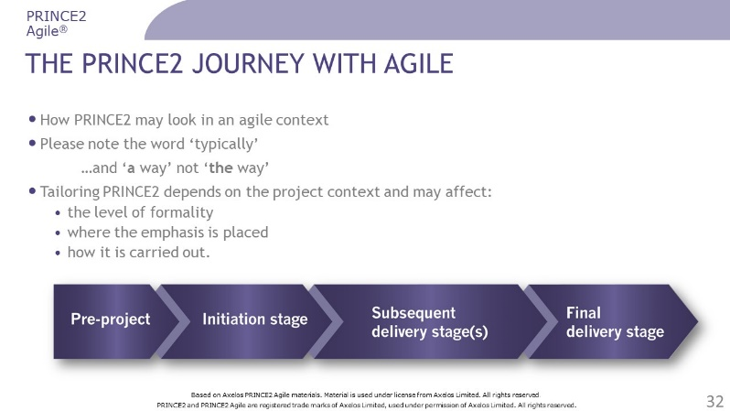 | ………………….………………………….………………  ……………………….……………….……………………  ………………………….……….…………………………  ………………….………….………………………………  …………………………………..…………………………  …………………………………..………………………………………………………..………………………………………..…………………………………..………………………………………..
Questions? | ………………….………………………….………………  ……………………….……………….……………………  ………………………….……….…………………………  ………………….………….………………………………  …………………………………..…………………………  …………………………………..………………………………………………………..………………………………………..…………………………………..………………………………………..

Review Questions – Introducing PRINCE2

1 | Which statement best relates to PRINCE2?  a) It should value responding to change more than following a plan  b) It should implement iterative feedback loops  c) It should apply a build-measure-learn model  d) It should be tailored to suit the project’s size, capability and risk exposure
2 | Which is a purpose of the change theme?  a) To ensure that the project delivers to the baseline specified during project initiation  b) To assess and control the uncertainty surrounding the baselined products  c) To establish mechanisms to prevent changes to the baselined aspects of the project  d) To assess how possible changes will impact the baselined aspects of the project
3 | Which is a purpose of the ’closing a project’ process?  a) To produce a stage plan for the activities of the final stage  b) To confirm that all of the project’s benefits have been realised  c) To establish that nothing further is required from the project  d) To agree what is required for accepting and executing project work
4 | Which of the following roles use the work package to take responsibility for delivery?  1) Team member  2) Project manager  3) Senior supplier  4) Team manager  a) 1 and 2  b) 1 and 4  c) 2 and 3  d) 3 and 4
5 | Which responsibilities are specifically assigned to the project manager?  1) Producing a project result that can achieve the defined benefits  2) Running the project within time, cost, scope, quality, risk and benefits tolerances  3) Representing the interests of those using the project’s products  4) Acting as the ultimate decision maker for the project  a) 1 and 2  b) 2 and 3  c) 3 and 4  d) 1 and 4

Check your answers on page 53.

Agile ways of working

Slides
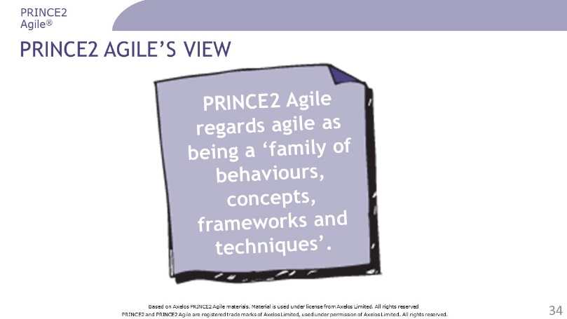 | ………………….………………………….………………  ……………………….……………….……………………  ………………………….……….…………………………  ………………….………….………………………………  …………………………………..…………………………  …………………………………..………………………………………………………..………………………………………..…………………………………..………………………………………..…………………………………..………………………………………..
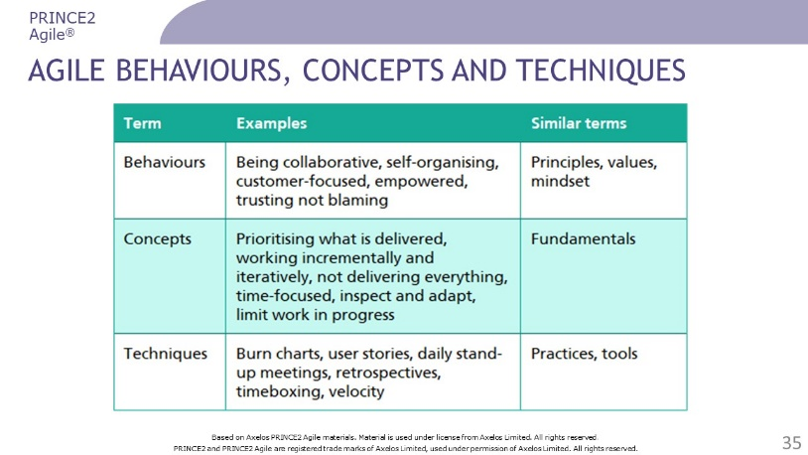 | ………………….………………………….………………  ……………………….……………….……………………  ………………………….……….…………………………  ………………….………….………………………………  …………………………………..…………………………  …………………………………..………………………………………………………..………………………………………..…………………………………..………………………………………..…………………………………..………………………………………..
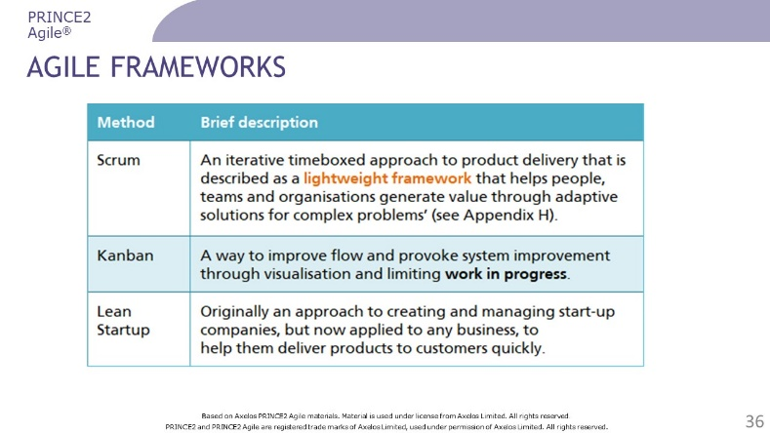 | ………………….………………………….………………  ……………………….……………….……………………  ………………………….……….…………………………  ………………….………….………………………………  …………………………………..…………………………  …………………………………..………………………………………………………..………………………………………..…………………………………..………………………………………..…………………………………..………………………………………..
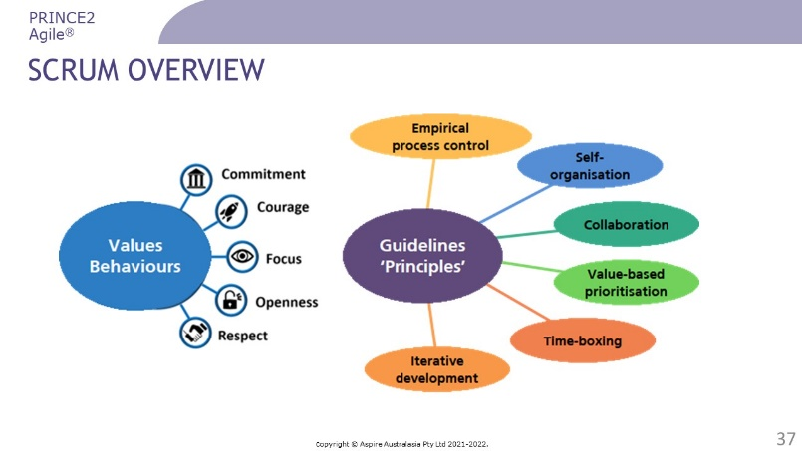 | ………………….………………………….………………  ……………………….……………….……………………  ………………………….……….…………………………  ………………….………….………………………………  …………………………………..…………………………  …………………………………..………………………………………………………..………………………………………..…………………………………..………………………………………..…………………………………..………………………………………..
………………….………………………….………………

……………………….……………….……………………

………………………….……….…………………………

………………….………….………………………………

…………………………………..…………………………

…………………………………..………………………………………………………..………………………………………..…………………………………..………………………………………..…………………………………..………………………………………..
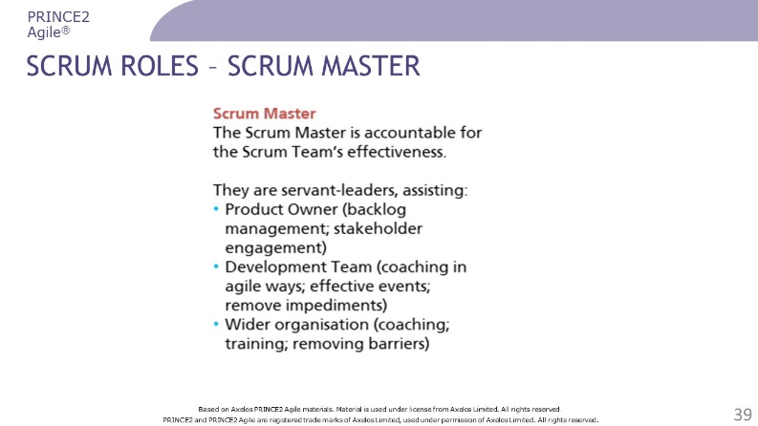 | ………………….………………………….………………  ……………………….……………….……………………  ………………………….……….…………………………  ………………….………….………………………………  …………………………………..…………………………  …………………………………..………………………………………………………..………………………………………..…………………………………..………………………………………..…………………………………..………………………………………..
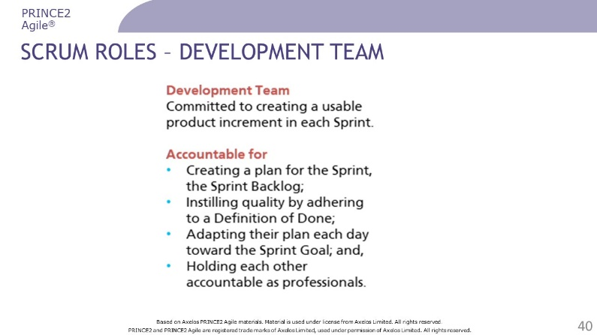 | ………………….………………………….………………  ……………………….……………….……………………  ………………………….……….…………………………  ………………….………….………………………………  …………………………………..…………………………  …………………………………..………………………………………………………..………………………………………..…………………………………..………………………………………..…………………………………..………………………………………..
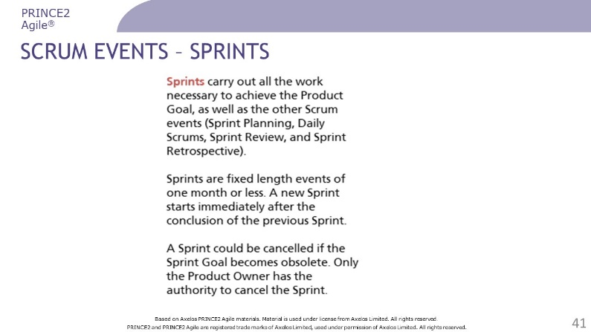 | ………………….………………………….………………  ……………………….……………….……………………  ………………………….……….…………………………  ………………….………….………………………………  …………………………………..…………………………  …………………………………..………………………………………………………..………………………………………..…………………………………..………………………………………..…………………………………..………………………………………..
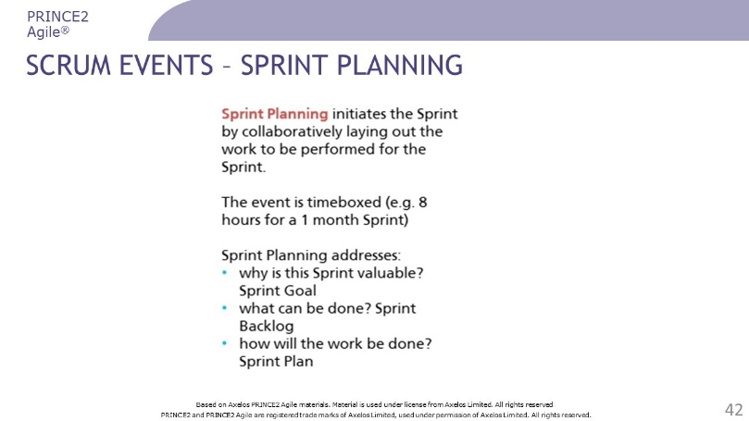 | ………………….………………………….………………  ……………………….……………….……………………  ………………………….……….…………………………  ………………….………….………………………………  …………………………………..…………………………  …………………………………..………………………………………………………..………………………………………..…………………………………..………………………………………..…………………………………..………………………………………..
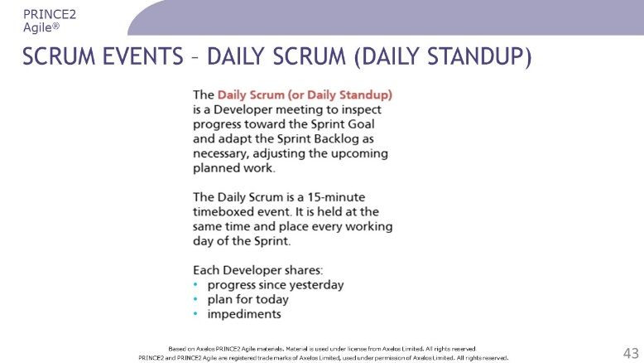 | ………………….………………………….………………  ……………………….……………….……………………  ………………………….……….…………………………  ………………….………….………………………………  …………………………………..…………………………  …………………………………..………………………………………………………..………………………………………..…………………………………..………………………………………..…………………………………..………………………………………..
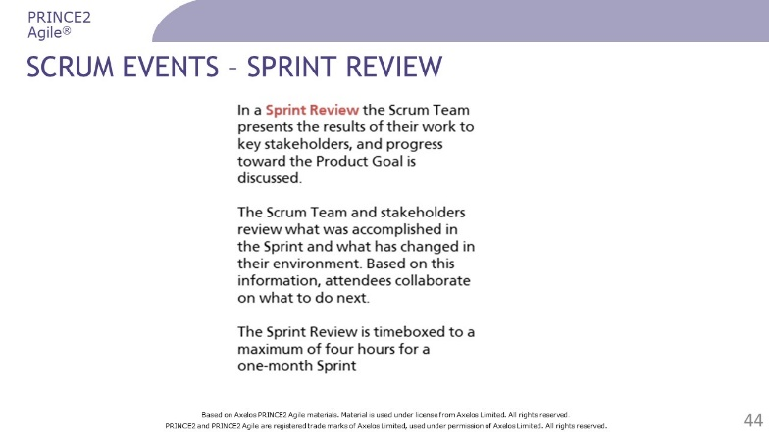 | ………………….………………………….………………  ……………………….……………….……………………  ………………………….……….…………………………  ………………….………….………………………………  …………………………………..…………………………  …………………………………..………………………………………………………..………………………………………..…………………………………..………………………………………..…………………………………..………………………………………..
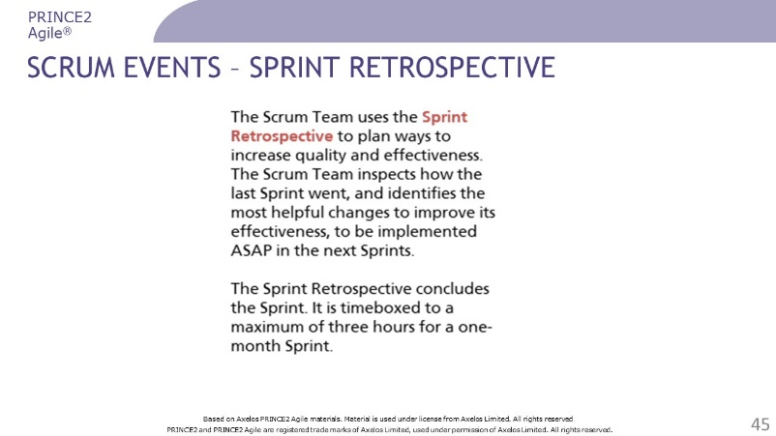 | ………………….………………………….………………  ……………………….……………….……………………  ………………………….……….…………………………  ………………….………….………………………………  …………………………………..…………………………  …………………………………..………………………………………………………..………………………………………..…………………………………..………………………………………..…………………………………..………………………………………..
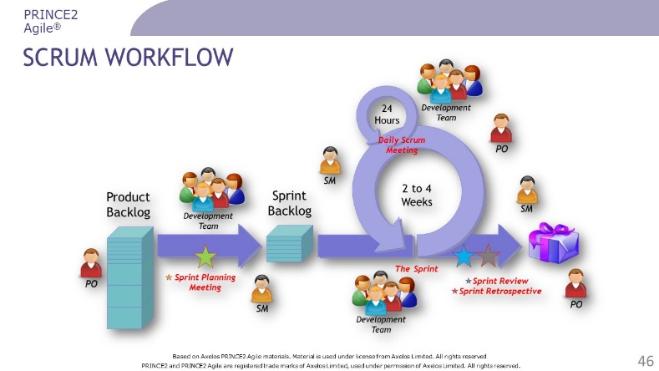 | ………………….………………………….………………  ……………………….……………….……………………  ………………………….……….…………………………  ………………….………….………………………………  …………………………………..…………………………  …………………………………..………………………………………………………..………………………………………..…………………………………..………………………………………..…………………………………..………………………………………..
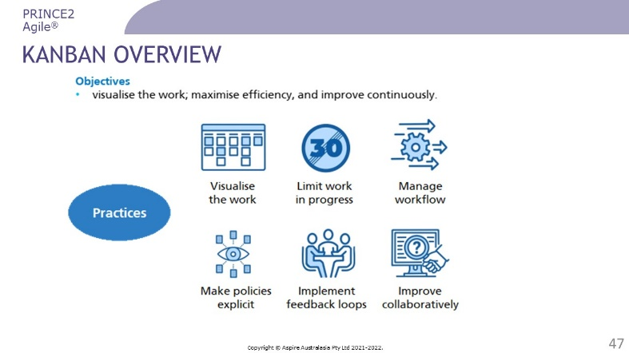 | ………………….………………………….………………  ……………………….……………….……………………  ………………………….……….…………………………  ………………….………….………………………………  …………………………………..…………………………  …………………………………..………………………………………………………..………………………………………..…………………………………..………………………………………..…………………………………..………………………………………..
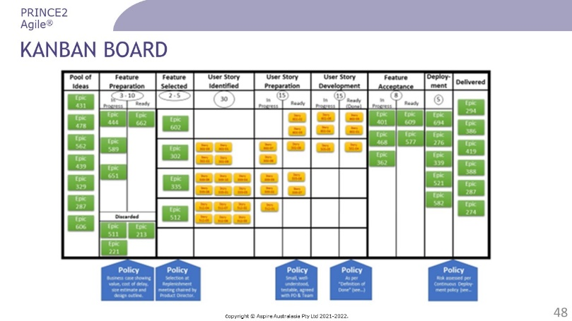 | ………………….………………………….………………  ……………………….……………….……………………  ………………………….……….…………………………  ………………….………….………………………………  …………………………………..…………………………  …………………………………..………………………………………………………..………………………………………..…………………………………..………………………………………..…………………………………..………………………………………..
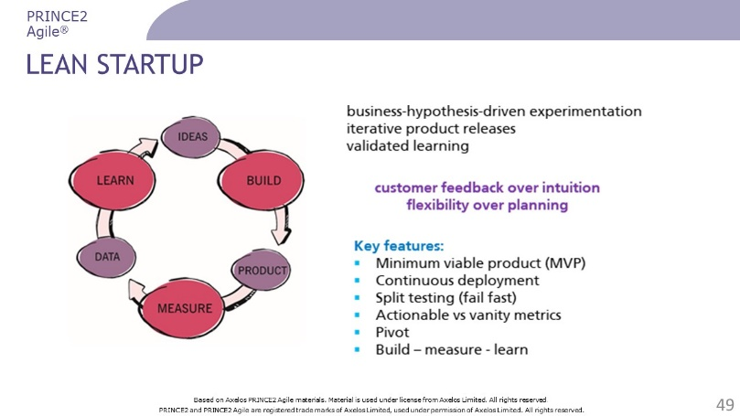 | ………………….………………………….………………  ……………………….……………….……………………  ………………………….……….…………………………  ………………….………….………………………………  …………………………………..…………………………  …………………………………..………………………………………………………..………………………………………..…………………………………..………………………………………..…………………………………..………………………………………..
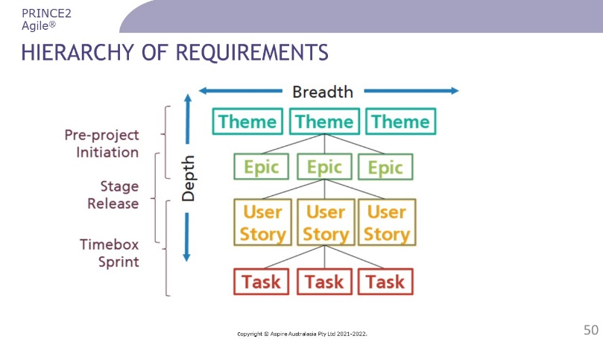 | ………………….………………………….………………  ……………………….……………….……………………  ………………………….……….…………………………  ………………….………….………………………………  …………………………………..…………………………  …………………………………..………………………………………………………..………………………………………..…………………………………..………………………………………..………………….………….……………………………………………..  …………………………………..………………………………………..
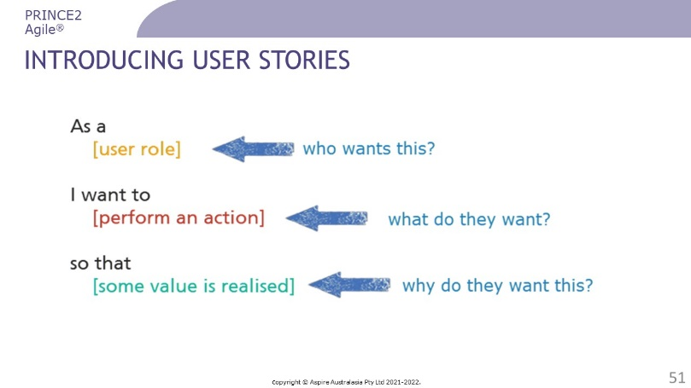 | ………………….………………………….………………  ……………………….……………….……………………  ………………………….……….…………………………  ………………….………….………………………………  …………………………………..…………………………  …………………………………..………………………………………………………..………………………………………..…………………………………..………………………………………..…………………………………..………………………………………..
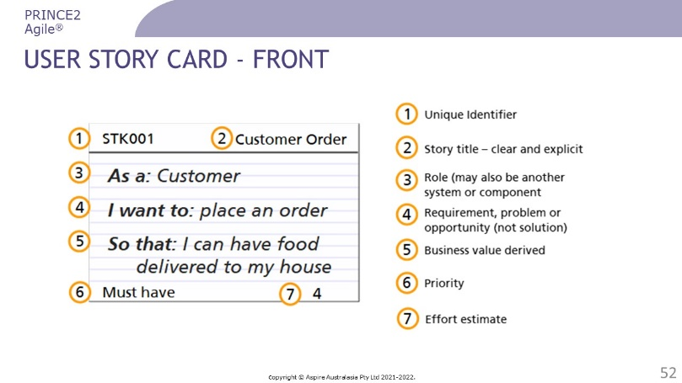 | ………………….………………………….………………  ……………………….……………….……………………  ………………………….……….…………………………  ………………….………….………………………………  …………………………………..…………………………  …………………………………..………………………………………………………..………………………………………..…………………………………..………………………………………..…………………………………..………………………………………..
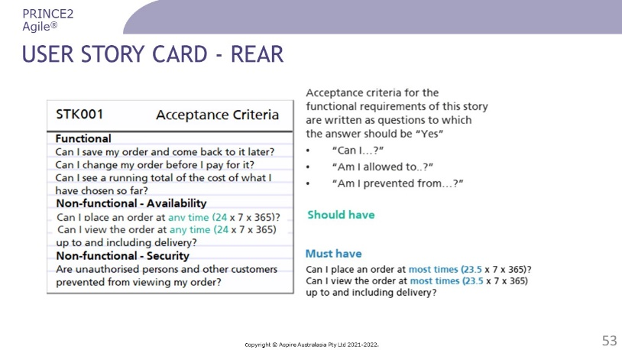 | ………………….………………………….………………  ……………………….……………….……………………  ………………………….……….…………………………  ………………….………….………………………………  …………………………………..…………………………  …………………………………..………………………………………………………..………………………………………..…………………………………..………………………………………..…………………………………..………………………………………..
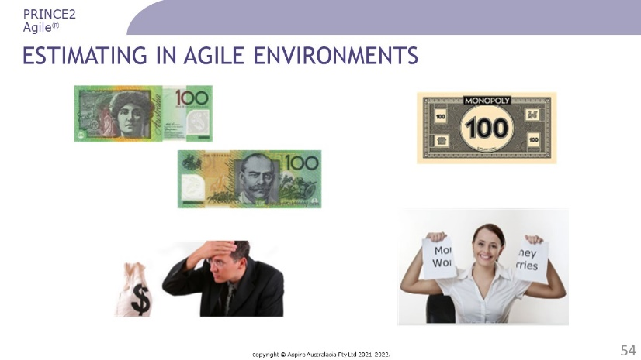 | ………………….………………………….………………  ……………………….……………….……………………  ………………………….……….…………………………  ………………….………….………………………………  …………………………………..…………………………  …………………………………..………………………………………………………..………………………………………..…………………………………..………………………………………..…………………………………..………………………………………..
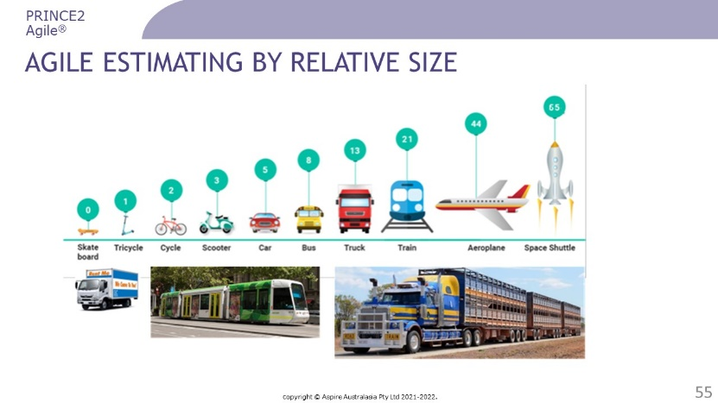 | ………………….………………………….………………  ……………………….……………….……………………  ………………………….……….…………………………  ………………….………….………………………………  …………………………………..…………………………  …………………………………..………………………………………………………..………………………………………..…………………………………..………………………………………..…………………………………..………………………………………..
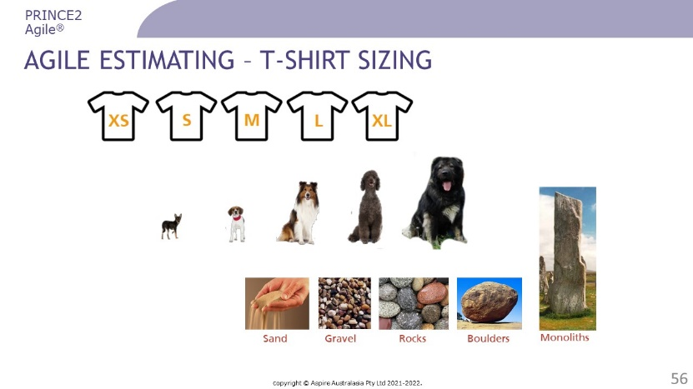 | ………………….………………………….………………  ……………………….……………….……………………  ………………………….……….…………………………  ………………….………….………………………………  …………………………………..…………………………  …………………………………..………………………………………………………..………………………………………..…………………………………..………………………………………..…………………………………..………………………………………..
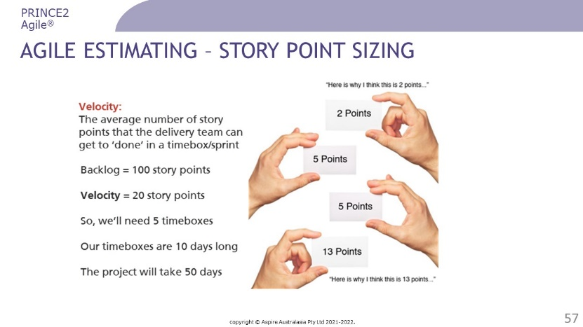 | ………………….………………………….………………  ……………………….……………….……………………  ………………………….……….…………………………  ………………….………….………………………………  …………………………………..…………………………  …………………………………..………………………………………………………..………………………………………..…………………………………..………………………………………..…………………………………..………………………………………..
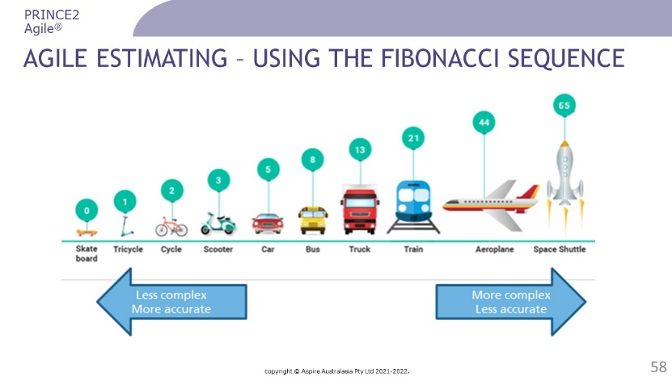 | ………………….………………………….………………  ……………………….……………….……………………  ………………………….……….…………………………  ………………….………….………………………………  …………………………………..…………………………  …………………………………..………………………………………………………..………………………………………..…………………………………..………………………………………..…………………………………..………………………………………..
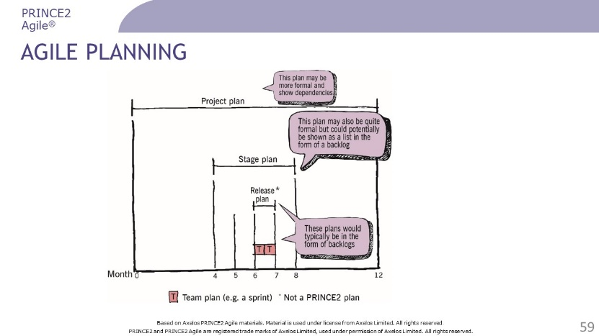 | ………………….………………………….………………  ……………………….……………….……………………  ………………………….……….…………………………  ………………….………….………………………………  …………………………………..…………………………  …………………………………..………………………………………………………..………………………………………..…………………………………..………………………………………..…………………………………..………………………………………..
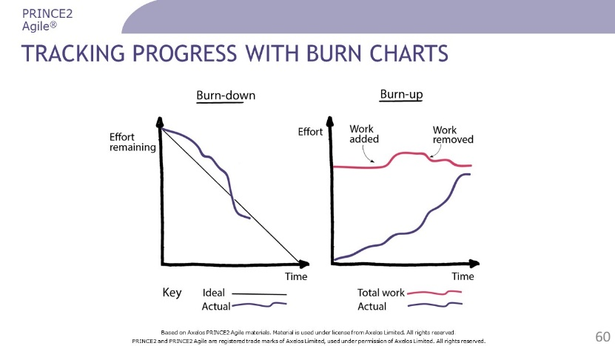 | ………………….………………………….………………  ……………………….……………….……………………  ………………………….……….…………………………  ………………….………….………………………………  …………………………………..…………………………  …………………………………..………………………………………………………..………………………………………..…………………………………..………………………………………..…………………………………..………………………………………..
Questions? | ………………….………………………….………………  ……………………….……………….……………………  ………………………….……….…………………………  ………………….………….………………………………  …………………………………..…………………………  …………………………………..………………………………………………………..………………………………………..…………………………………..………………………………………..…………………………………..………………………………………..

Review Questions – Agile ways of working

1 | What Scrum role is responsible for prioritising items on the product backlog?  a) Team manager  b) Scrum master  c) Product owner  d) Development team
2 | What has two lines, one increasing to show the amount of work completed, and the other showing the total amount of work to be done?  a) Kanban Board  b) Gantt chart  c) Burn-down chart  d) Burn-up chart
3 | Which describes a minimum viable product?  a) It is the project product resulting from delivery of only the Must Have requirements  b) It is a tool that assesses the level of risk associated with using agile in a PRINCE2 environment  c) It may take the form of a simple experiment or prototype developed to promote learning  d) It should go into operational use in order to realise benefits for the customer
4 | What is NOT typically included in a User Story?  a) The role that will benefit from the requirement  b) The fully defined solution that satisfies the requirement  c) The business value expected from the requirement  d) The action that the user will be able to take
5 | Which agile framework includes the concept of an MVP?  a) Lean startup  b) Kanban  c) PRINCE2 Agile  d) Scrum
Check your answers on page 53.

Blending PRINCE2 and Agile

Slides
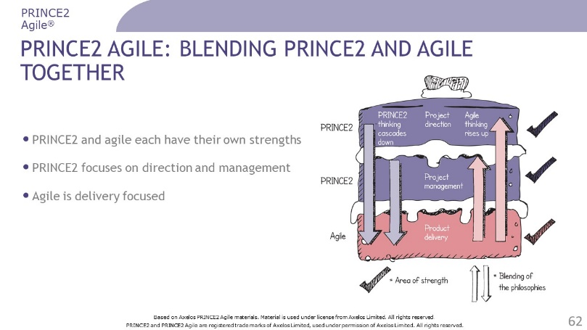 | ………………….………………………….………………  ……………………….……………….……………………  ………………………….……….…………………………  ………………….………….………………………………  …………………………………..…………………………  …………………………………..………………………………………………………..………………………………………..…………………………………..………………………………………..…………………………………..………………………………………..
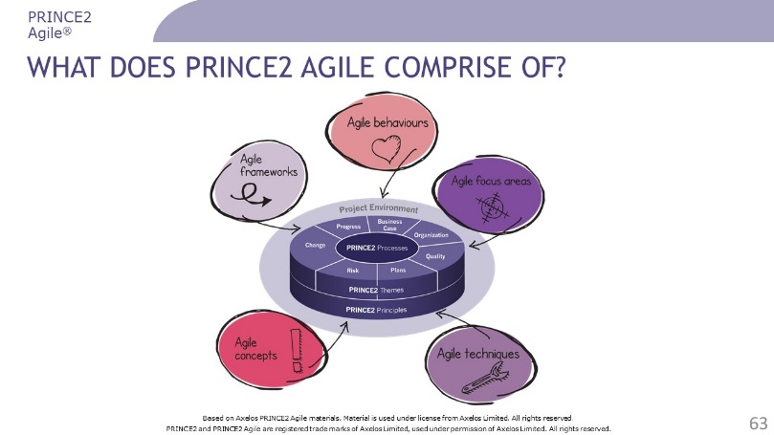 | ………………….………………………….………………  ……………………….……………….……………………  ………………………….……….…………………………  ………………….………….………………………………  …………………………………..…………………………  …………………………………..………………………………………………………..………………………………………..…………………………………..………………………………………..…………………………………..………………………………………..
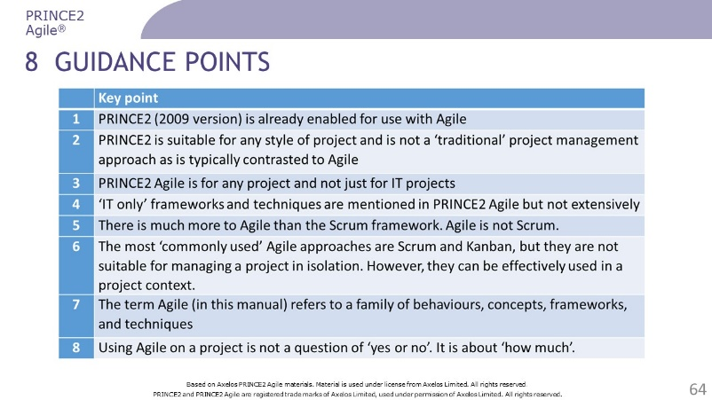 | ………………….………………………….………………  ……………………….……………….……………………  ………………………….……….…………………………  ………………….………….………………………………  …………………………………..…………………………  …………………………………..………………………………………………………..………………………………………..…………………………………..………………………………………..…………………………………..………………………………………..
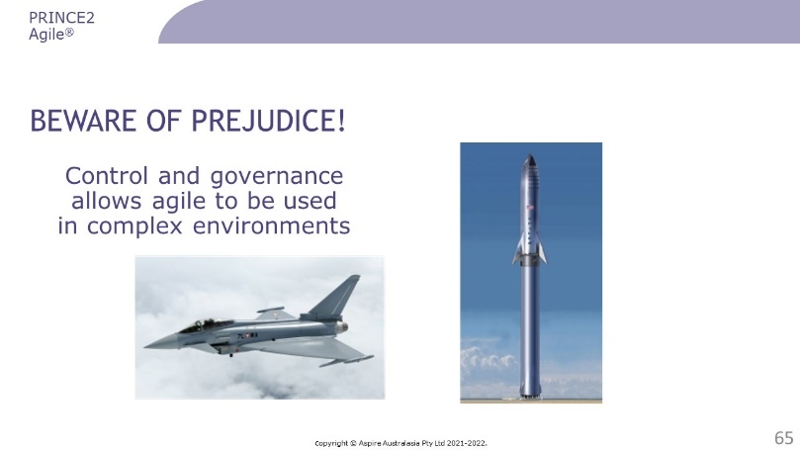 | ………………….………………………….………………  ……………………….……………….……………………  ………………………….……….…………………………  ………………….………….………………………………  …………………………………..…………………………  …………………………………..………………………………………………………..………………………………………..…………………………………..………………………………………..…………………………………..………………………………………..
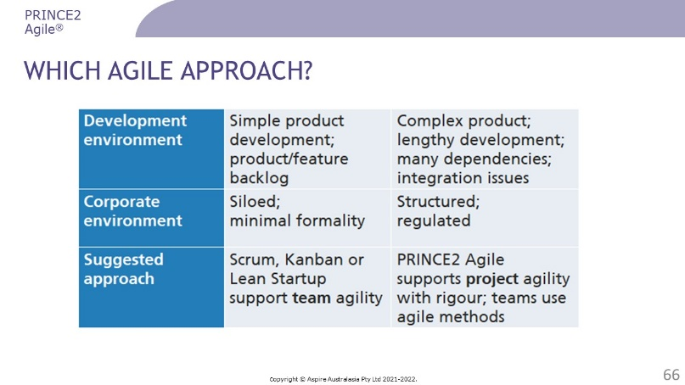 | ………………….………………………….………………  ……………………….……………….……………………  ………………………….……….…………………………  ………………….………….………………………………  …………………………………..…………………………  …………………………………..………………………………………………………..………………………………………..…………………………………..………………………………………..…………………………………..………………………………………..
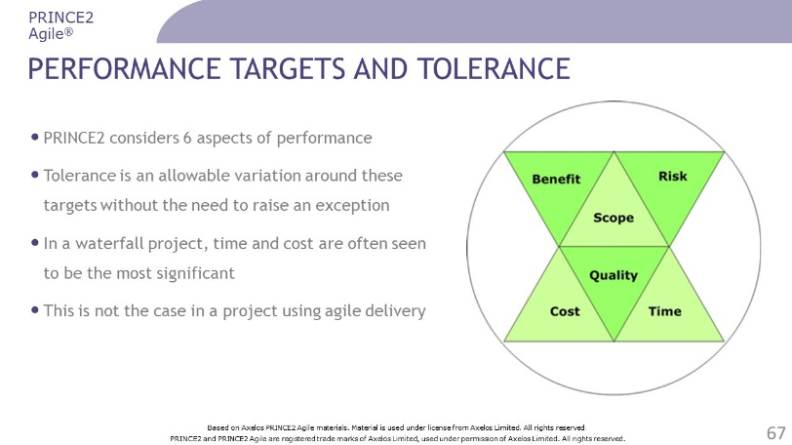 | ………………….………………………….………………  ……………………….……………….……………………  ………………………….……….…………………………  ………………….………….………………………………  …………………………………..…………………………  …………………………………..………………………………………………………..………………………………………..…………………………………..………………………………………..…………………………………..………………………………………..
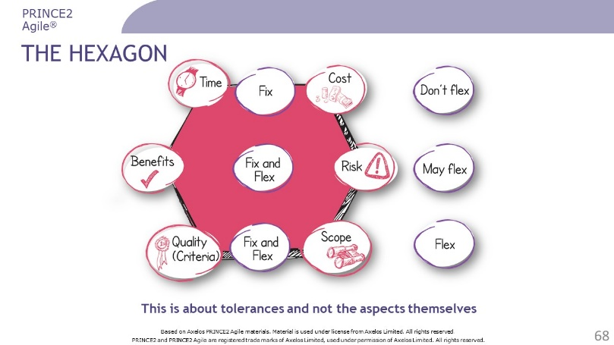 | ………………….………………………….………………  ……………………….……………….……………………  ………………………….……….…………………………  ………………….………….………………………………  …………………………………..…………………………  …………………………………..………………………………………………………..………………………………………..…………………………………..………………………………………..…………………………………..………………………………………..
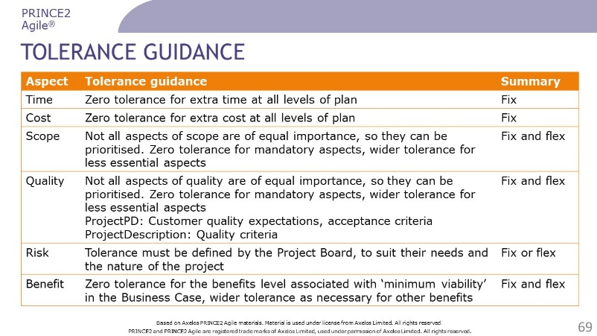 | ………………….………………………….………………  ……………………….……………….……………………  ………………………….……….…………………………  ………………….………….………………………………  …………………………………..…………………………  …………………………………..………………………………………………………..………………………………………..…………………………………..………………………………………..…………………………………..………………………………………..
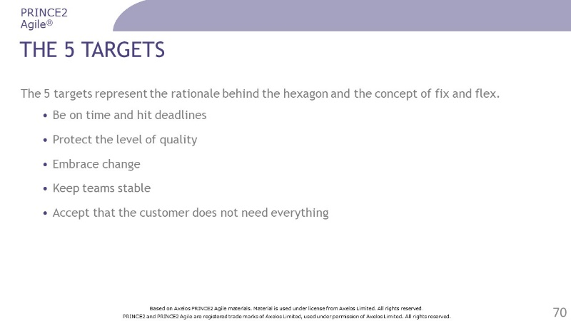 | ………………….………………………….………………  ……………………….……………….……………………  ………………………….……….…………………………  ………………….………….………………………………  …………………………………..…………………………  …………………………………..………………………………………………………..………………………………………..…………………………………..………………………………………..…………………………………..………………………………………..
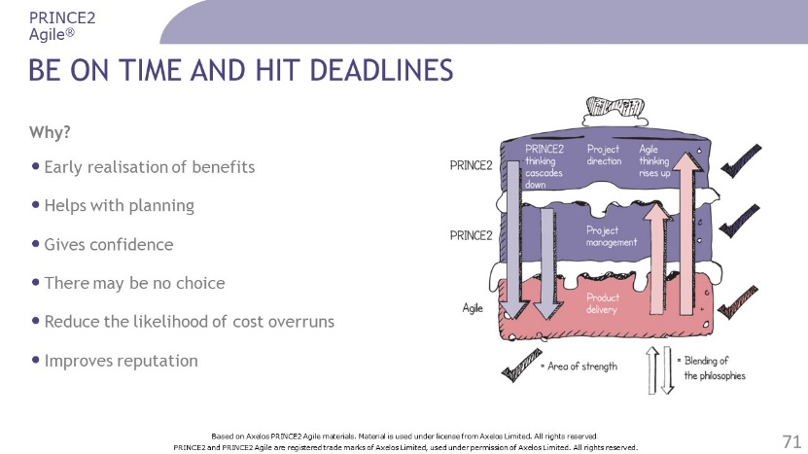 | ………………….………………………….………………  ……………………….……………….……………………  ………………………….……….…………………………  ………………….………….………………………………  …………………………………..…………………………  …………………………………..………………………………………………………..………………………………………..…………………………………..………………………………………..…………………………………..………………………………………..
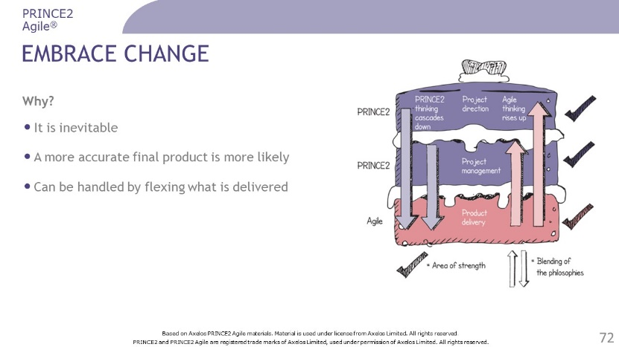 | ………………….………………………….………………  ……………………….……………….……………………  ………………………….……….…………………………  ………………….………….………………………………  …………………………………..…………………………  …………………………………..………………………………………………………..………………………………………..…………………………………..………………………………………..…………………………………..………………………………………..
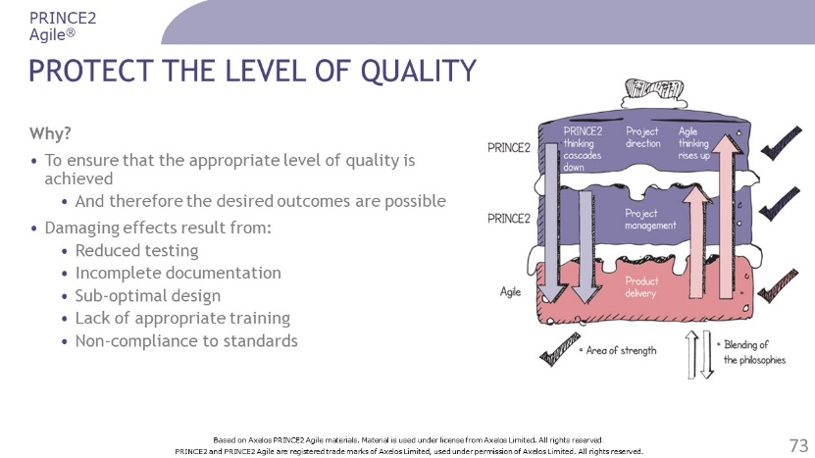 | ………………….………………………….………………  ……………………….……………….……………………  ………………………….……….…………………………  ………………….………….………………………………  …………………………………..…………………………  …………………………………..………………………………………………………..………………………………………..…………………………………..………………………………………..…………………………………..………………………………………..
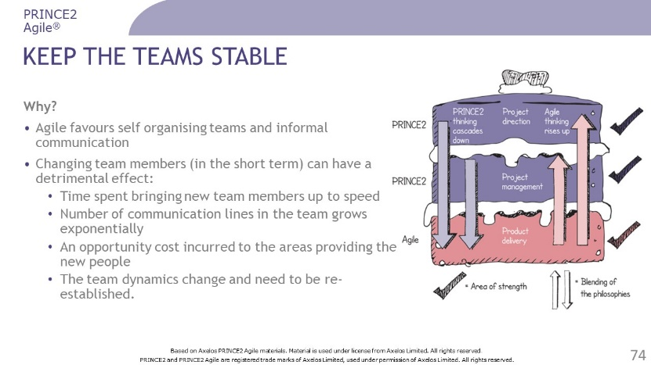 | ………………….………………………….………………  ……………………….……………….……………………  ………………………….……….…………………………  ………………….………….………………………………  …………………………………..…………………………  …………………………………..………………………………………………………..………………………………………..…………………………………..………………………………………..…………………………………..………………………………………..
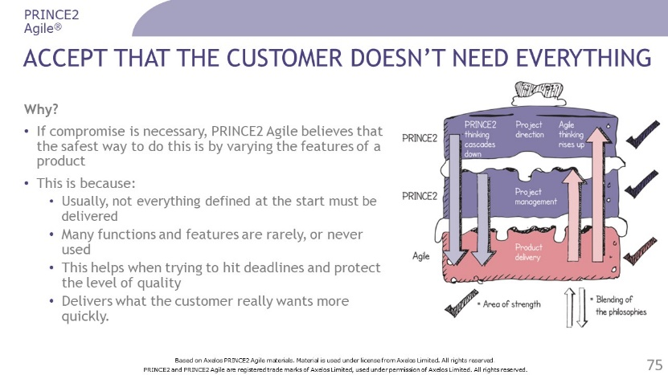 | ………………….………………………….………………  ……………………….……………….……………………  ………………………….……….…………………………  ………………….………….………………………………  …………………………………..…………………………  …………………………………..………………………………………………………..………………………………………..…………………………………..………………………………………..…………………………………..………………………………………..
Questions? | ………………….………………………….………………  ……………………….……………….……………………  ………………………….……….…………………………  ………………….………….………………………………  …………………………………..…………………………  …………………………………..………………………………………………………..………………………………………..…………………………………..………………………………………..…………………………………..………………………………………..

Review Questions – Blending PRINCE2 and agile

1 | Which statement explains the PRINCE2 Agile behaviour of 'self-organisation'?  a) It enables information to pass freely in a culture of commitment  b) It seeks out feedback from stakeholders collaboratively  c) It allows everyone to know the situation and there are no surprises  d) It helps to create mutual respect throughout the project
2 | Which statement explains the PRINCE2 Agile behaviour of 'exploration'?  a) It uses the people closest to the work as they know best how to get the work done  b) It encourages people to use the most effective channel to communicate  c) It displays progress information so everyone knows the situation  d) It promotes the use of learning to improve the products produced by the project
3 | Which statement BEST explains the target 'embrace change' for flexible delivery?  a) It delivers an early realisation of benefits  b) It checks that the customer needs everything they have asked for  c) It allows for a more accurate final product  d) It leads to a lower cost of ownership throughout the life of the product
4 | Which statement summarises the setting of the time tolerance for a project in an agile context?  a) Time tolerance is flexed  b) Time tolerance is flexed  c) Time tolerance can be fixed or flexed  d) Time tolerance can be fixed and flexed
5 | Which statement BEST explains the 'be on time and hit deadlines' target for flexible delivery?  a) It allows the project to deliver early realization of benefits  b) It supports the trading of requirements with others of a similar size  c) It avoids the use of extra people to improve progress within a sprint  d) It maintains the activities that ensure the level of quality

More questions on the next page

6 | Which statement about the 'keep teams stable' target is CORRECT?  a) It allows team members to change according to the needs of the project  b) It allows for a more accurate final product  c) It is achieved by ensuring that support teams have appropriate training  d) It encourages the customer to raise new ideas
7 | Which statement about the 'accept that the customer doesn't need everything' target is CORRECT?  a) It is achieved by swapping features for others of a similar size  b) It is achieved by setting the project baseline at the correct level  c) It prioritises the features that the customer really wants  d) It encourages the customer to raise new ideas
8 | Which statement explains the target 'protect the level of quality' for flexible delivery?  a) It helps with planning dependencies between projects  b) It accepts that not everything that is defined must be delivered  c) It leads to a lower cost throughout the life of a product  d) It improves your reputation with your customer
9 | Which two statements about the supplier representative are CORRECT?  1. They communicate guidance on areas of technical compliance.  2. They perform initial technical assurance.  3. They consolidate and communicate the views of the customer.  4. They provide support on releasing into operational use when needed.  a) 1 and 2  b) 2 and 3  c) 3 and 4  d) 1 and 4
10 | Which describes PRINCE2 Agile, according to the eight guidance points?  a) It assumes that the outputs will relate to IT systems  b) It is suitable for use on any project, if appropriately tailored  c) It requires that the project is relatively small and simple  d) It requires that the project has high levels of uncertainty

Check your answers on page 55.

Tailoring PRINCE2 for agile

Slides
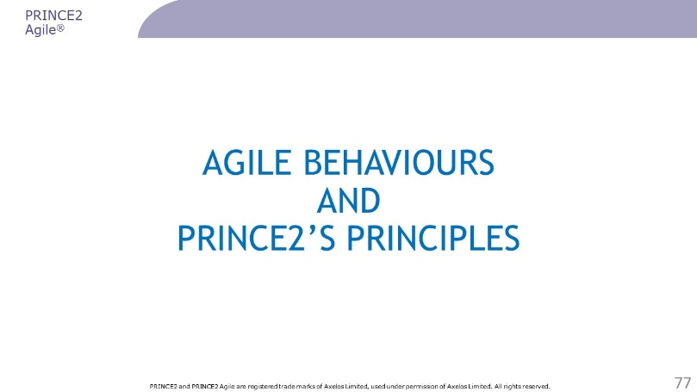 | ………………….………………………….………………  ……………………….……………….……………………  ………………………….……….…………………………  ………………….………….………………………………  …………………………………..…………………………  …………………………………..………………………………………………………..………………………………………..…………………………………..………………………………………..…………………………………..………………………………………..
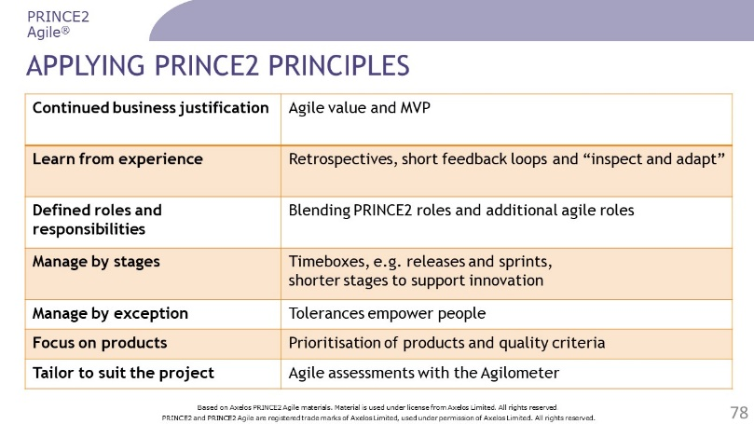 | ………………….………………………….………………  ……………………….……………….……………………  ………………………….……….…………………………  ………………….………….………………………………  …………………………………..…………………………  …………………………………..………………………………………………………..………………………………………..…………………………………..………………………………………..…………………………………..………………………………………..…………………………………..………………………………………..
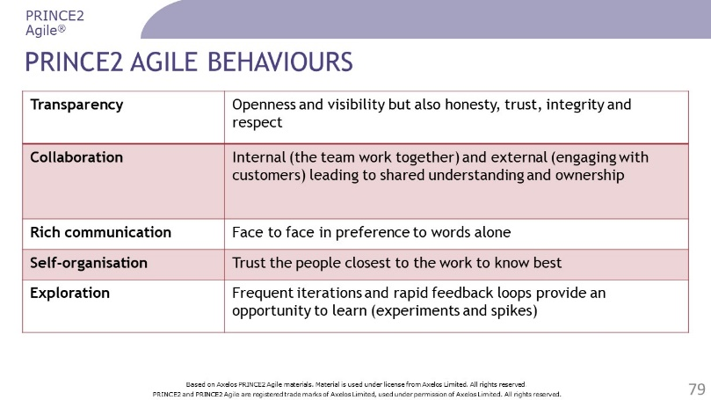 | ………………….………………………….………………  ……………………….……………….……………………  ………………………….……….…………………………  ………………….………….………………………………  …………………………………..…………………………  …………………………………..………………………………………………………..………………………………………..…………………………………..………………………………………..…………………………………..………………………………………..…………………………………..………………………………………..
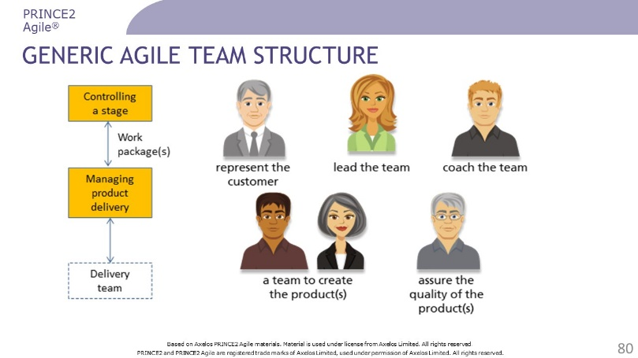 | ………………….………………………….………………  ……………………….……………….……………………  ………………………….……….…………………………  ………………….………….………………………………  …………………………………..…………………………  …………………………………..………………………………………………………..………………………………………..…………………………………..………………………………………..…………………………………..………………………………………..…………………………………..………………………………………..
………………….………………………….………………

……………………….……………….……………………

………………………….……….…………………………

………………….………….………………………………

…………………………………..…………………………

…………………………………..………………………………………………………..………………………………………..…………………………………..………………………………………..…………………………………..………………………………………..…………………………………..………………………………………..
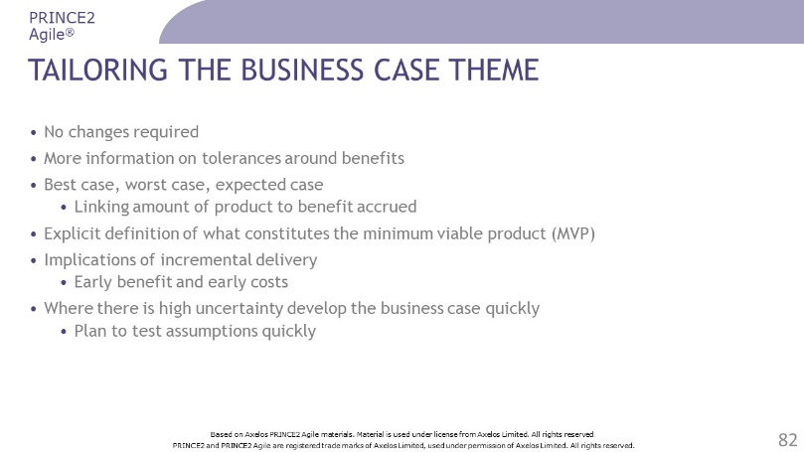 | ………………….………………………….………………  ……………………….……………….……………………  ………………………….……….…………………………  ………………….………….………………………………  …………………………………..…………………………  …………………………………..………………………………………………………..………………………………………..…………………………………..………………………………………..…………………………………..………………………………………..…………………………………..………………………………………..
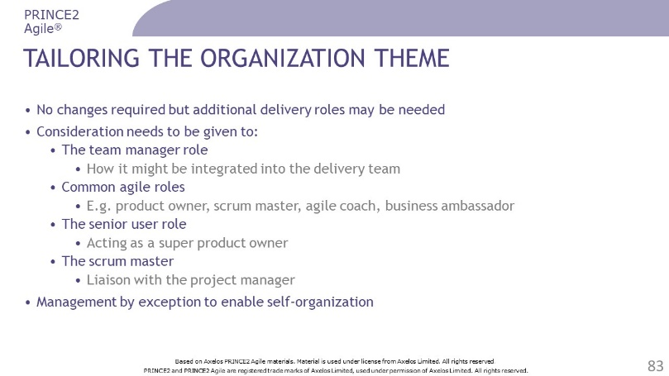 | ………………….………………………….………………  ……………………….……………….……………………  ………………………….……….…………………………  ………………….………….………………………………  …………………………………..…………………………  …………………………………..………………………………………………………..………………………………………..…………………………………..………………………………………..…………………………………..………………………………………..…………………………………..………………………………………..
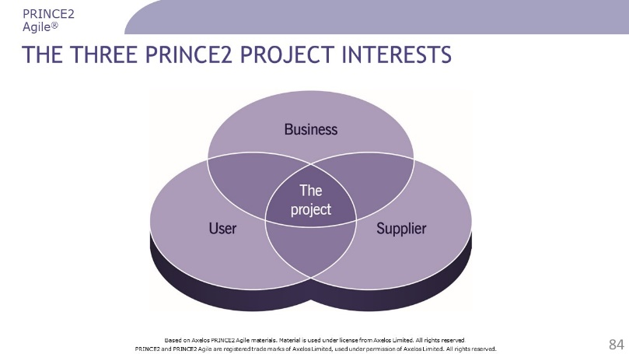 | ………………….………………………….………………  ……………………….……………….……………………  ………………………….……….…………………………  ………………….………….………………………………  …………………………………..…………………………  …………………………………..………………………………………………………..………………………………………..…………………………………..………………………………………..…………………………………..………………………………………..…………………………………..………………………………………..
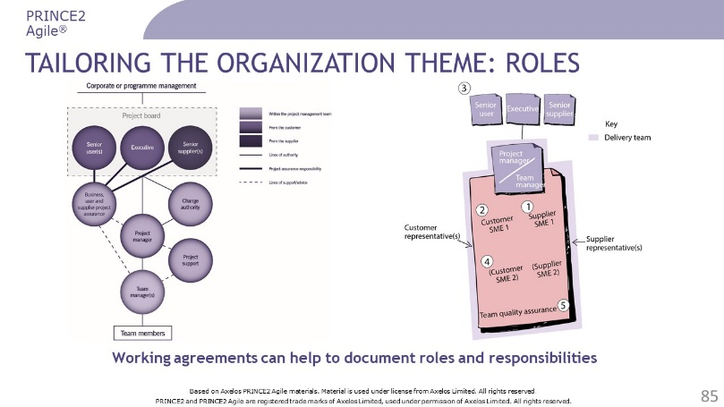 | ………………….………………………….………………  ……………………….……………….……………………  ………………………….……….…………………………  ………………….………….………………………………  …………………………………..…………………………  …………………………………..………………………………………………………..………………………………………..…………………………………..………………………………………..…………………………………..………………………………………..…………………………………..………………………………………..
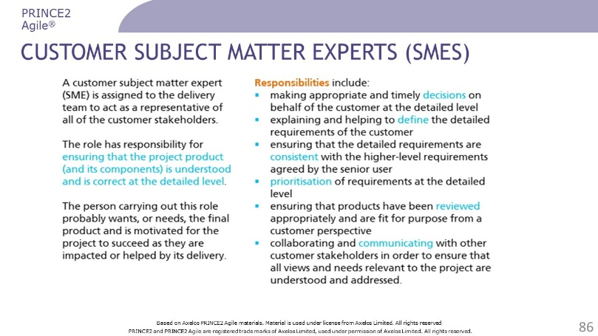 | ………………….………………………….………………  ……………………….……………….……………………  ………………………….……….…………………………  ………………….………….………………………………  …………………………………..…………………………  …………………………………..………………………………………………………..………………………………………..…………………………………..………………………………………..…………………………………..………………………………………..…………………………………..………………………………………..
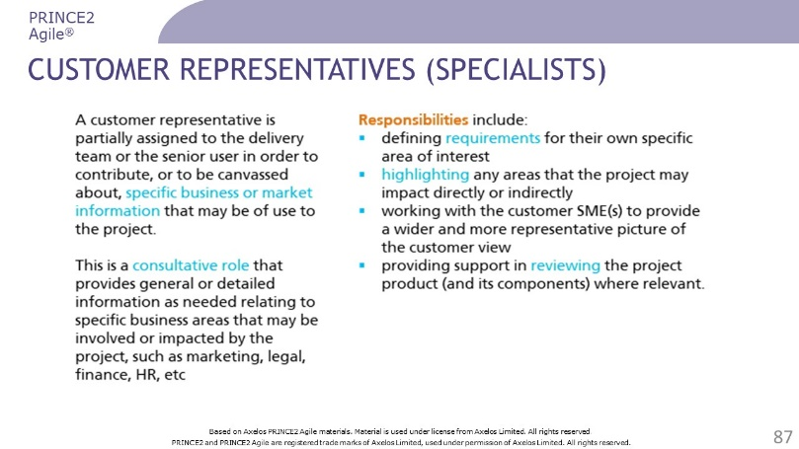 | ………………….………………………….………………  ……………………….……………….……………………  ………………………….……….…………………………  ………………….………….………………………………  …………………………………..…………………………  …………………………………..………………………………………………………..………………………………………..…………………………………..………………………………………..…………………………………..………………………………………..…………………………………..………………………………………..
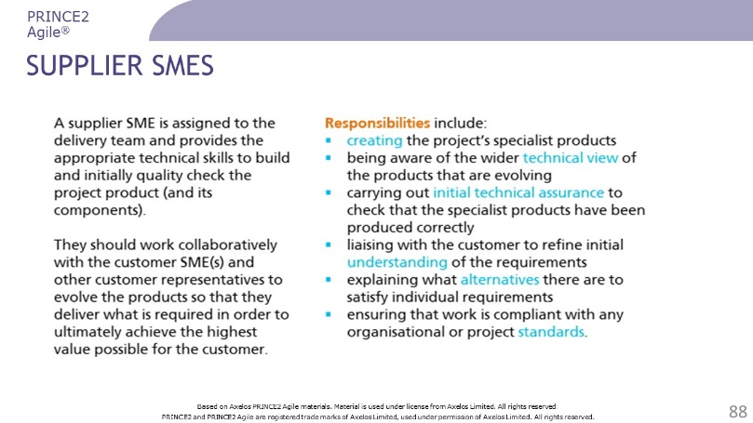 | ………………….………………………….………………  ……………………….……………….……………………  ………………………….……….…………………………  ………………….………….………………………………  …………………………………..…………………………  …………………………………..………………………………………………………..………………………………………..…………………………………..………………………………………..…………………………………..………………………………………..…………………………………..………………………………………..
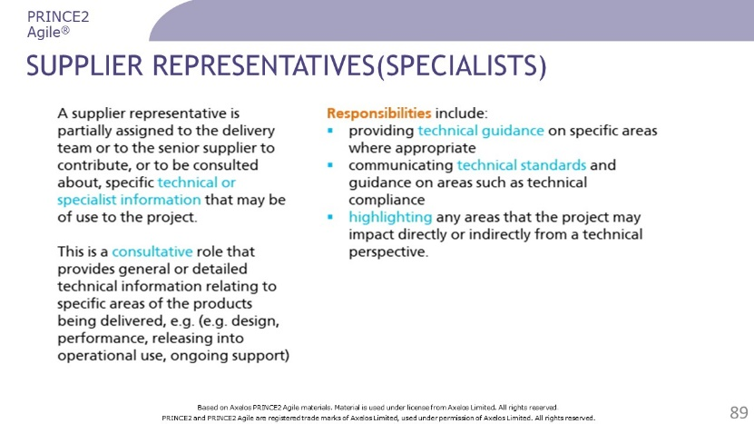 | ………………….………………………….………………  ……………………….……………….……………………  ………………………….……….…………………………  ………………….………….………………………………  …………………………………..…………………………  …………………………………..………………………………………………………..………………………………………..…………………………………..………………………………………..…………………………………..………………………………………..…………………………………..………………………………………..
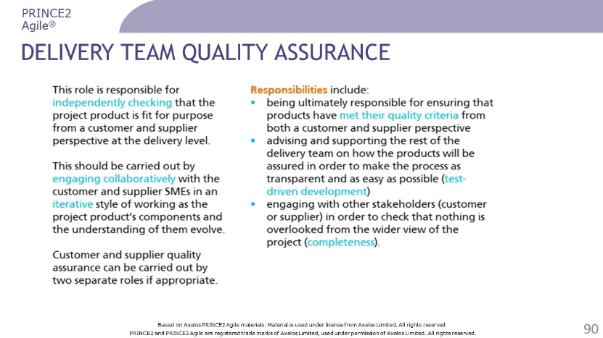 | ………………….………………………….………………  ……………………….……………….……………………  ………………………….……….…………………………  ………………….………….………………………………  …………………………………..…………………………  …………………………………..………………………………………………………..………………………………………..…………………………………..………………………………………..…………………………………..………………………………………..…………………………………..………………………………………..
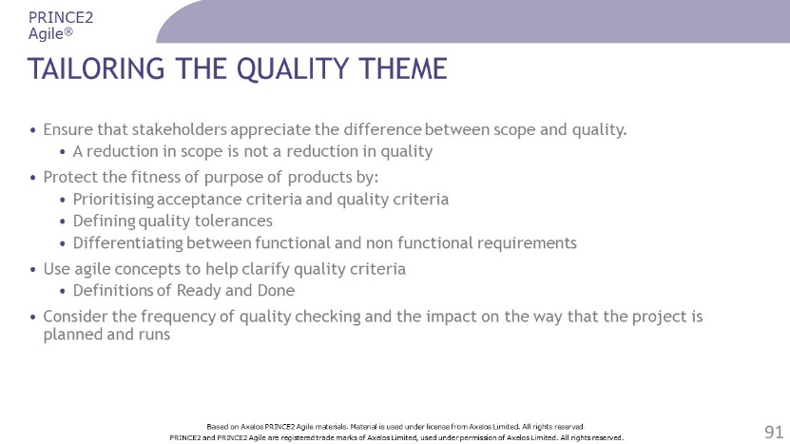 | ………………….………………………….………………  ……………………….……………….……………………  ………………………….……….…………………………  ………………….………….………………………………  …………………………………..…………………………  …………………………………..………………………………………………………..………………………………………..…………………………………..………………………………………..…………………………………..………………………………………..…………………………………..………………………………………..
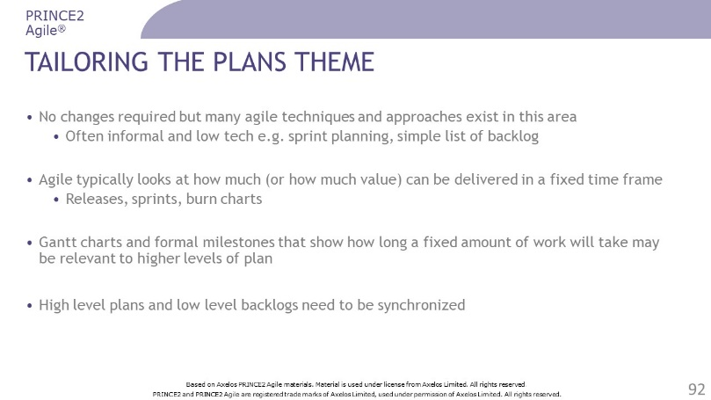 | ………………….………………………….………………  ……………………….……………….……………………  ………………………….……….…………………………  ………………….………….………………………………  …………………………………..…………………………  …………………………………..………………………………………………………..………………………………………..…………………………………..………………………………………..…………………………………..………………………………………..…………………………………..………………………………………..
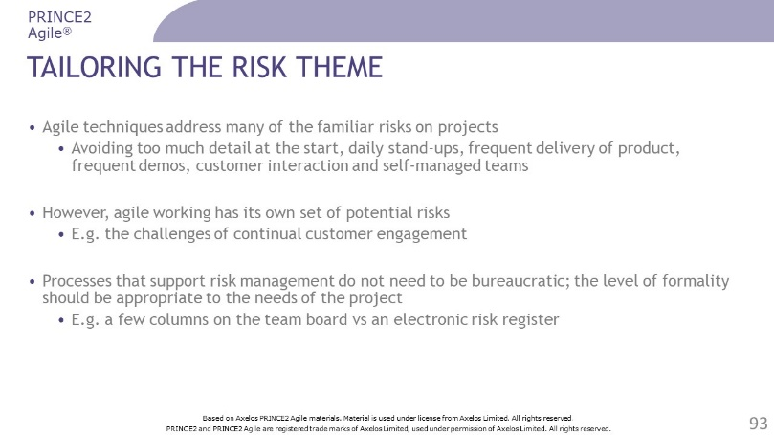 | ………………….………………………….………………  ……………………….……………….……………………  ………………………….……….…………………………  ………………….………….………………………………  …………………………………..…………………………  …………………………………..………………………………………………………..………………………………………..…………………………………..………………………………………..…………………………………..………………………………………..…………………………………..………………………………………..
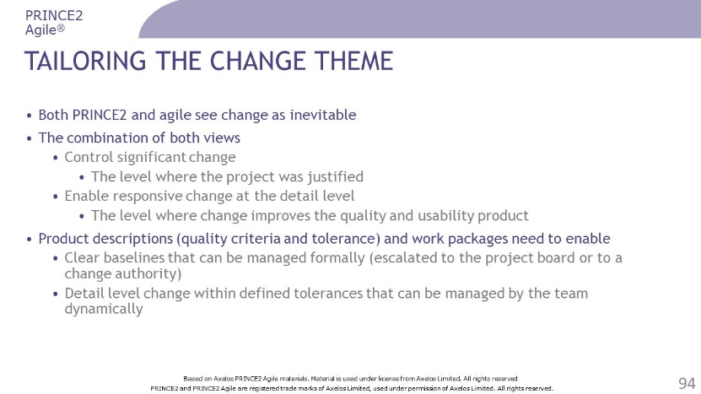 | ………………….………………………….………………  ……………………….……………….……………………  ………………………….……….…………………………  ………………….………….………………………………  …………………………………..…………………………  …………………………………..………………………………………………………..………………………………………..…………………………………..………………………………………..…………………………………..………………………………………..…………………………………..………………………………………..
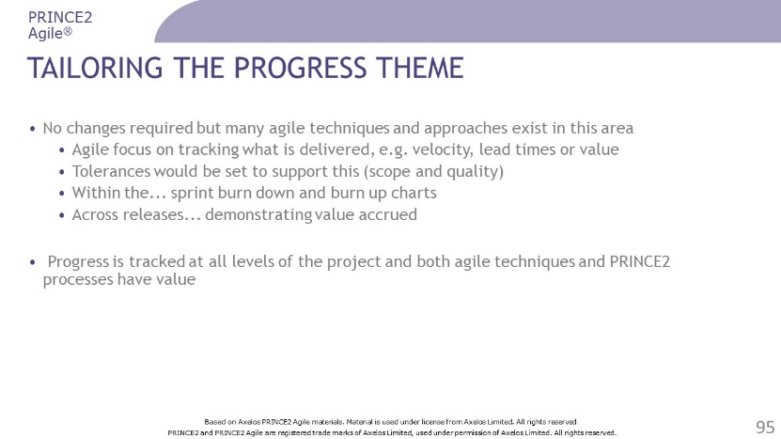 | ………………….………………………….………………  ……………………….……………….……………………  ………………………….……….…………………………  ………………….………….………………………………  …………………………………..…………………………  …………………………………..………………………………………………………..………………………………………..…………………………………..………………………………………..…………………………………..………………………………………..…………………………………..………………………………………..
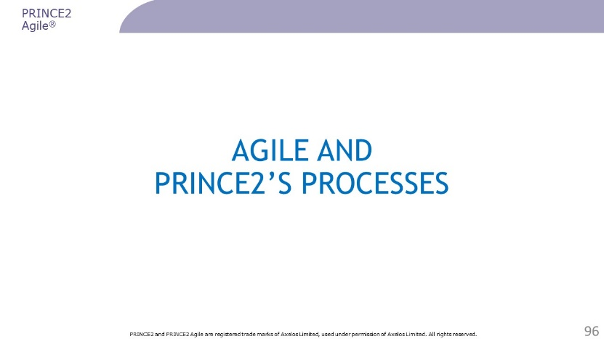 | ………………….………………………….………………  ……………………….……………….……………………  ………………………….……….…………………………  ………………….………….………………………………  …………………………………..…………………………  …………………………………..………………………………………………………..………………………………………..…………………………………..………………………………………..…………………………………..………………………………………..…………………………………..………………………………………..
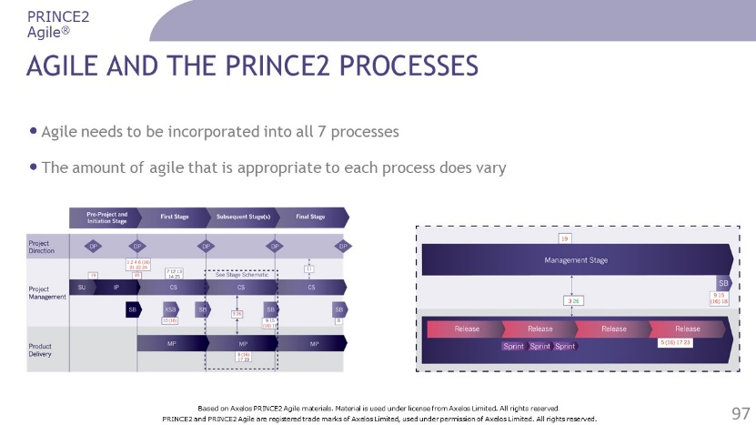 | ………………….………………………….………………  ……………………….……………….……………………  ………………………….……….…………………………  ………………….………….………………………………  …………………………………..…………………………  …………………………………..………………………………………………………..………………………………………..…………………………………..………………………………………..…………………………………..………………………………………..…………………………………..………………………………………..
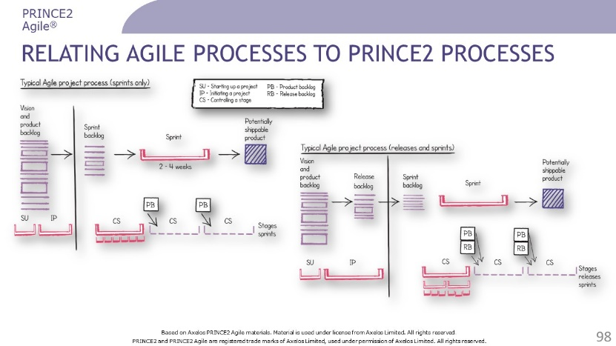 | ………………….………………………….………………  ……………………….……………….……………………  ………………………….……….…………………………  ………………….………….………………………………  …………………………………..…………………………  …………………………………..………………………………………………………..………………………………………..…………………………………..………………………………………..…………………………………..………………………………………..…………………………………..………………………………………..
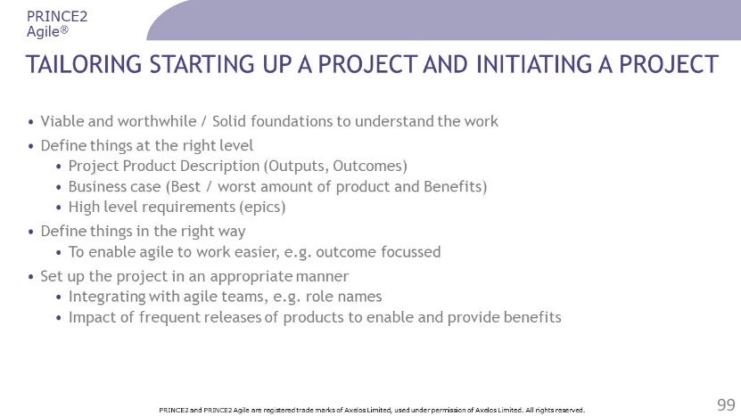 | ………………….………………………….………………  ……………………….……………….……………………  ………………………….……….…………………………  ………………….………….………………………………  …………………………………..…………………………  …………………………………..………………………………………………………..………………………………………..…………………………………..………………………………………..…………………………………..………………………………………..…………………………………..………………………………………..
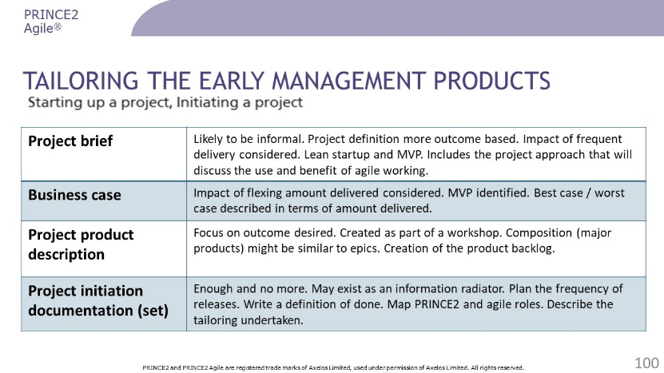 | ………………….………………………….………………  ……………………….……………….……………………  ………………………….……….…………………………  ………………….………….………………………………  …………………………………..…………………………  …………………………………..………………………………………………………..………………………………………..…………………………………..………………………………………..…………………………………..………………………………………..…………………………………..………………………………………..
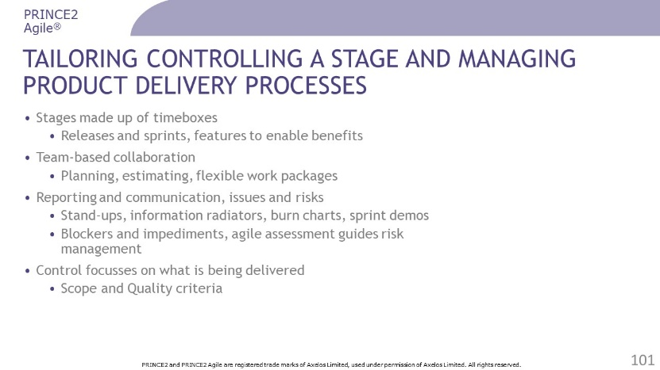 | ………………….………………………….………………  ……………………….……………….……………………  ………………………….……….…………………………  ………………….………….………………………………  …………………………………..…………………………  …………………………………..………………………………………………………..………………………………………..…………………………………..………………………………………..…………………………………..………………………………………..…………………………………..………………………………………..
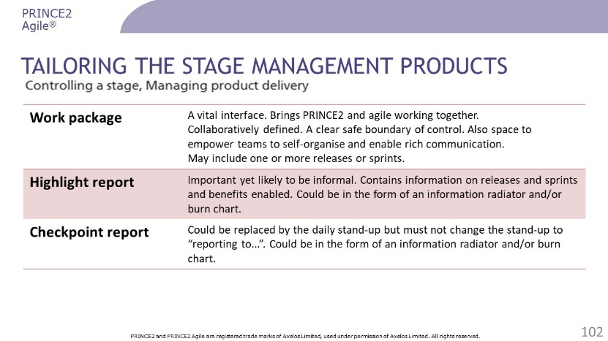 | ………………….………………………….………………  ……………………….……………….……………………  ………………………….……….…………………………  ………………….………….………………………………  …………………………………..…………………………  …………………………………..………………………………………………………..………………………………………..…………………………………..………………………………………..…………………………………..………………………………………..…………………………………..………………………………………..
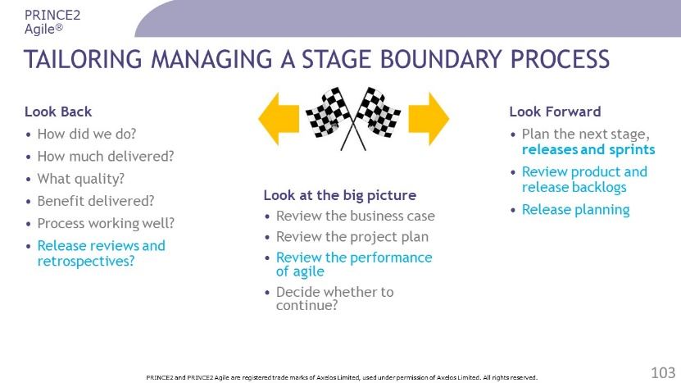 | ………………….………………………….………………  ……………………….……………….……………………  ………………………….……….…………………………  ………………….………….………………………………  …………………………………..…………………………  …………………………………..………………………………………………………..………………………………………..…………………………………..………………………………………..…………………………………..………………………………………..…………………………………..………………………………………..
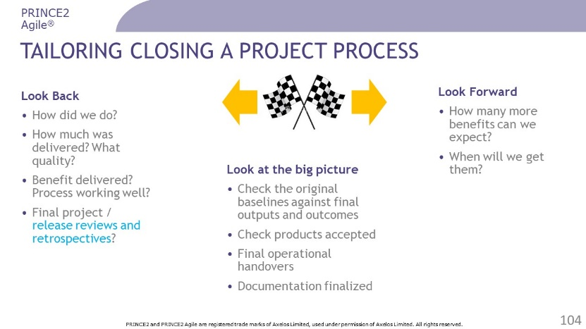 | ………………….………………………….………………  ……………………….……………….……………………  ………………………….……….…………………………  ………………….………….………………………………  …………………………………..…………………………  …………………………………..………………………………………………………..………………………………………..…………………………………..………………………………………..…………………………………..………………………………………..…………………………………..………………………………………..
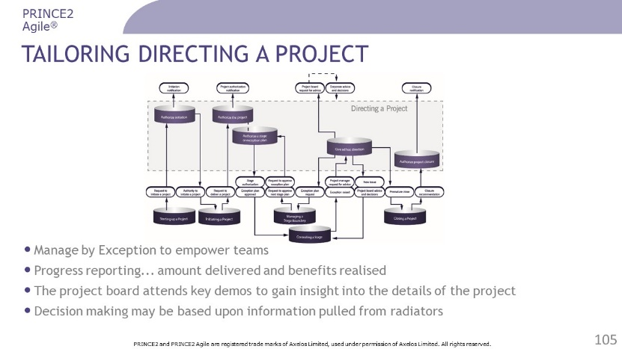 | ………………….………………………….………………  ……………………….……………….……………………  ………………………….……….…………………………  ………………….………….………………………………  …………………………………..…………………………  …………………………………..………………………………………………………..………………………………………..…………………………………..………………………………………..…………………………………..………………………………………..…………………………………..………………………………………..
Questions? | ………………….………………………….………………  ……………………….……………….……………………  ………………………….……….…………………………  ………………….………….………………………………  …………………………………..…………………………  …………………………………..………………………………………………………..………………………………………..…………………………………..………………………………………..…………………………………..………………………………………..…………………………………..………………………………………..

Review Questions – Tailoring PRINCE2 for agile

1 | How is the 'focus on products' principle applied in an agile context?  a) By assessing the risks associated with delivery  b) By using shorter stages to produce the product in an innovative way  c) By using the inspect and adapt technique to continually receive feedback  d) By flexing what is delivered to make it easier to stay in control
2 | Which statement explains how the 'manage by exception' principle is applied in an agile context?  a) It supports the 'inspect and adapt' technique  b) It supports many short stages in situations of high uncertainty  c) It prioritises quality criteria at product level  d) It empowers people to self-organise and stay in control
3 | Which statement about the PRINCE2 Agile business case is CORRECT, when describing best-case and worst-case scenarios?  a) It is likely that detailed requirements can be mapped directly to the business case  b) It is unlikely that high-level requirements can be mapped directly to the business case  c) It is unlikely that detailed requirements can be mapped directly to the business case  d) It is unlikely that intermediate-level requirements can be mapped directly to the business case
4 | Which BEST describes how both PRINCE2 and agile see change?  a) Unwelcome  b) Inevitable  c) Avoidable  d) Desirable
5 | When can a product be used as a primary source of information with respect to progress?  a) It has met the acceptance criteria  b) It has been planned in a sprint  c) It has been delivered to budget  d) It has used the right number of resources
Check your answers on page 55.

PRINCE2 Agile’s Focus Areas

Slides
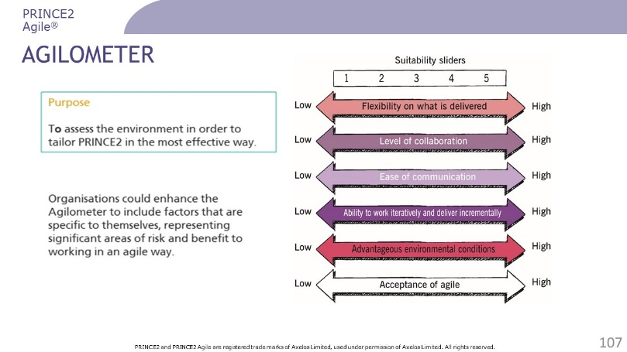 | ………………….………………………….………………  ……………………….……………….……………………  ………………………….……….…………………………  ………………….………….………………………………  …………………………………..…………………………  …………………………………..………………………………………………………..………………………………………..…………………………………..………………………………………..…………………………………..………………………………………..…………………………………..………………………………………..…………………………………..………………………………………..
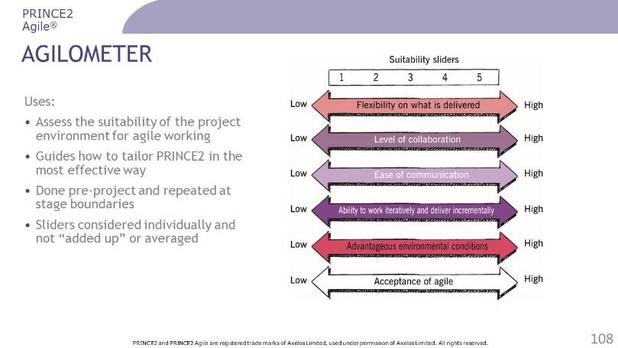 | ………………….………………………….………………  ……………………….……………….……………………  ………………………….……….…………………………  ………………….………….………………………………  …………………………………..…………………………  …………………………………..………………………………………………………..………………………………………..…………………………………..………………………………………..…………………………………..………………………………………..…………………………………..………………………………………..…………………………………..………………………………………..
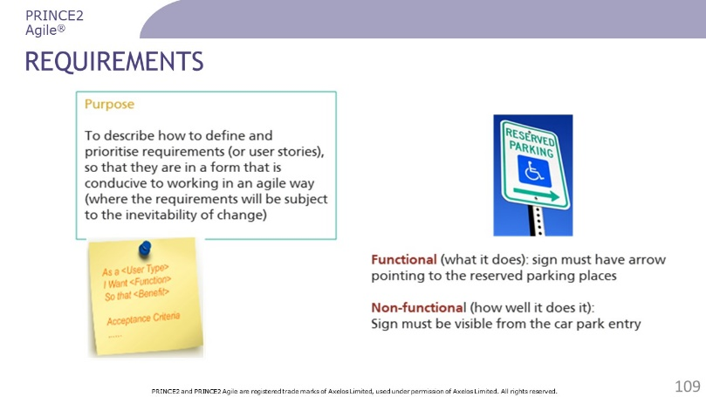 | ………………….………………………….………………  ……………………….……………….……………………  ………………………….……….…………………………  ………………….………….………………………………  …………………………………..…………………………  …………………………………..………………………………………………………..………………………………………..…………………………………..………………………………………..…………………………………..………………………………………..…………………………………..………………………………………..…………………………………..………………………………………..
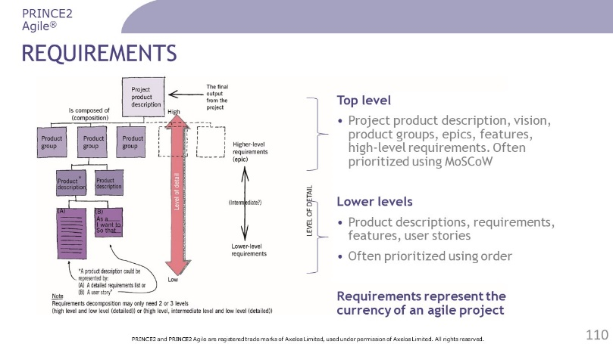 | ………………….………………………….………………  ……………………….……………….……………………  ………………………….……….…………………………  ………………….………….………………………………  …………………………………..…………………………  …………………………………..………………………………………………………..………………………………………..…………………………………..………………………………………..…………………………………..………………………………………..…………………………………..………………………………………..…………………………………..………………………………………..
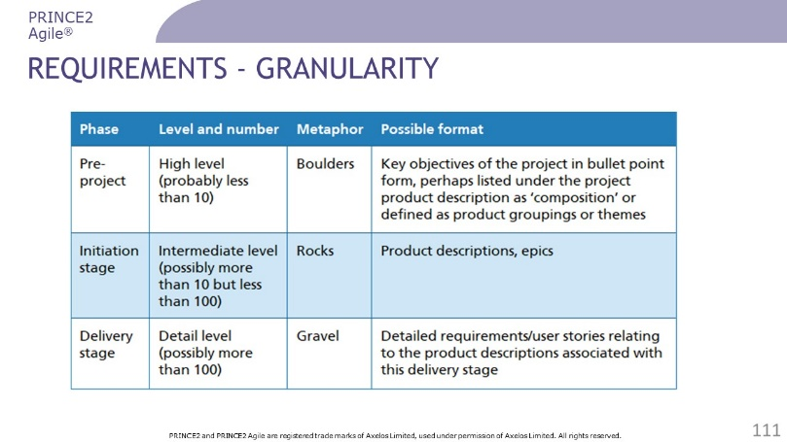 | ………………….………………………….………………  ……………………….……………….……………………  ………………………….……….…………………………  ………………….………….………………………………  …………………………………..…………………………  …………………………………..………………………………………………………..………………………………………..…………………………………..………………………………………..…………………………………..………………………………………..…………………………………..………………………………………..…………………………………..………………………………………..
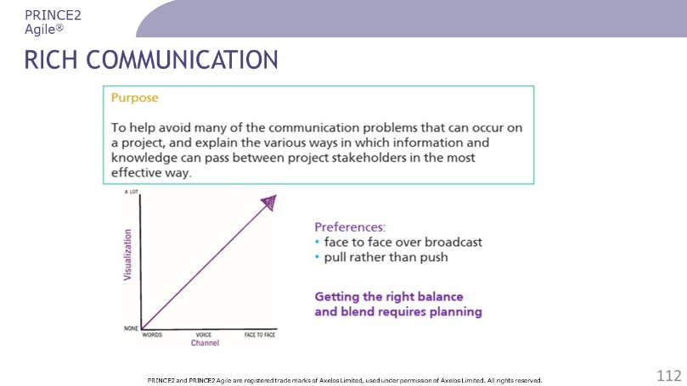 | ………………….………………………….………………  ……………………….……………….……………………  ………………………….……….…………………………  ………………….………….………………………………  …………………………………..…………………………  …………………………………..………………………………………………………..………………………………………..…………………………………..………………………………………..…………………………………..………………………………………..…………………………………..………………………………………..…………………………………..………………………………………..
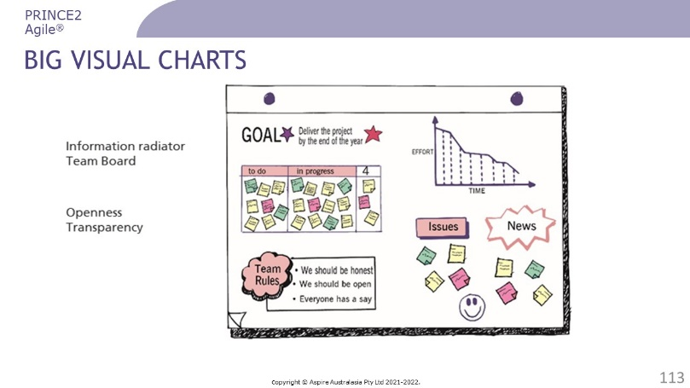 | ………………….………………………….………………  ……………………….……………….……………………  ………………………….……….…………………………  ………………….………….………………………………  …………………………………..…………………………  …………………………………..………………………………………………………..………………………………………..…………………………………..………………………………………..…………………………………..………………………………………..…………………………………..………………………………………..…………………………………..………………………………………..
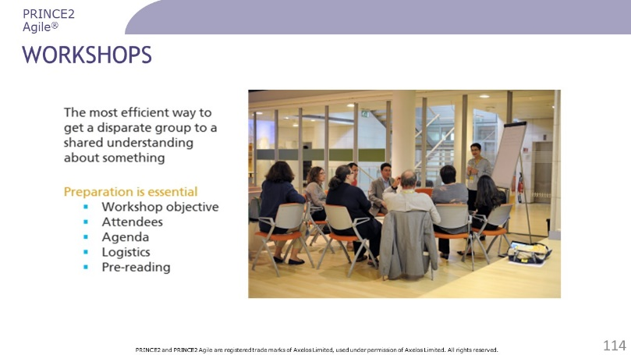 | ………………….………………………….………………  ……………………….……………….……………………  ………………………….……….…………………………  ………………….………….………………………………  …………………………………..…………………………  …………………………………..………………………………………………………..………………………………………..…………………………………..………………………………………..…………………………………..………………………………………..…………………………………..………………………………………..…………………………………..………………………………………..
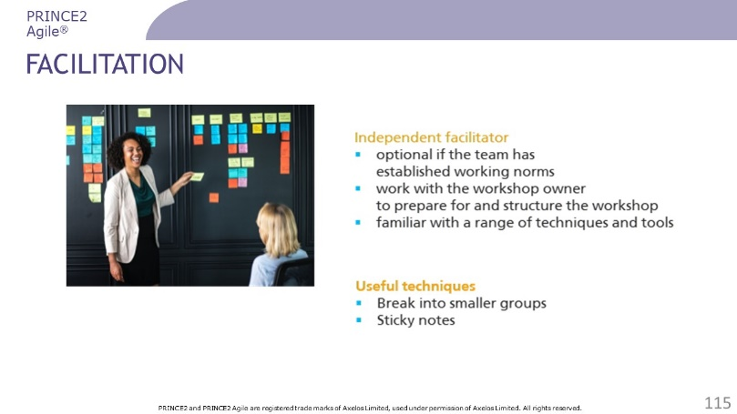 | ………………….………………………….………………  ……………………….……………….……………………  ………………………….……….…………………………  ………………….………….………………………………  …………………………………..…………………………  …………………………………..………………………………………………………..………………………………………..…………………………………..………………………………………..…………………………………..………………………………………..…………………………………..………………………………………..…………………………………..………………………………………..
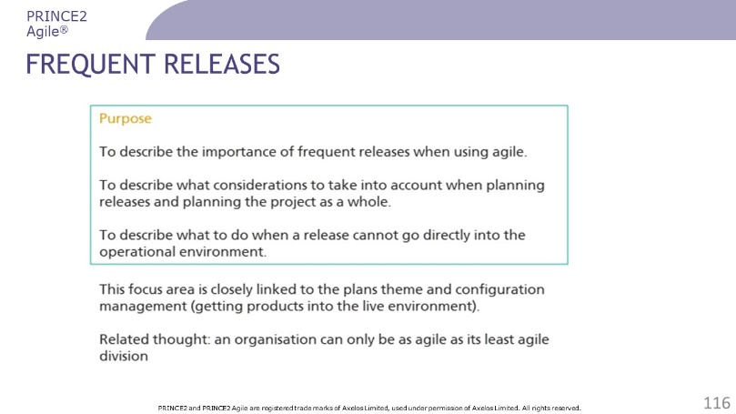 | ………………….………………………….………………  ……………………….……………….……………………  ………………………….……….…………………………  ………………….………….………………………………  …………………………………..…………………………  …………………………………..………………………………………………………..………………………………………..…………………………………..………………………………………..…………………………………..………………………………………..…………………………………..………………………………………..…………………………………..………………………………………..
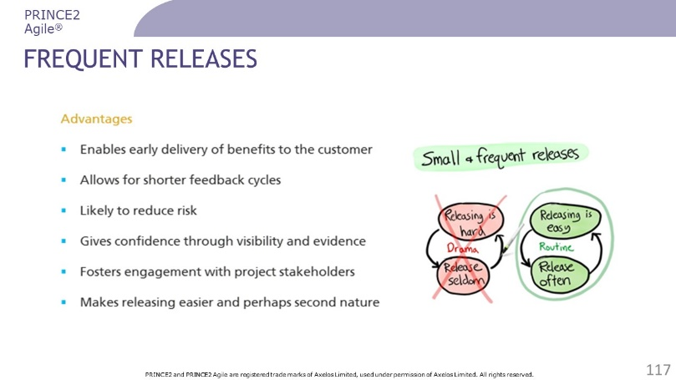 | ………………….………………………….………………  ……………………….……………….……………………  ………………………….……….…………………………  ………………….………….………………………………  …………………………………..…………………………  …………………………………..………………………………………………………..………………………………………..…………………………………..………………………………………..…………………………………..………………………………………..…………………………………..………………………………………..…………………………………..………………………………………..
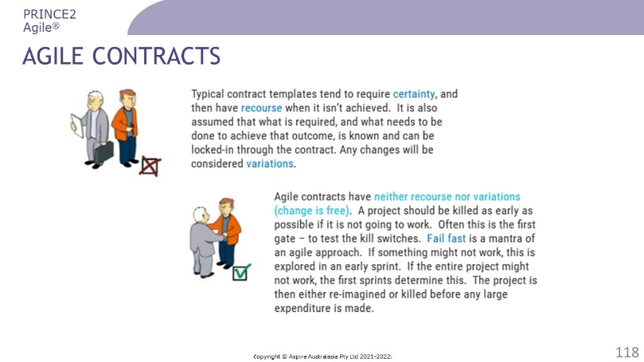 | ………………….………………………….………………  ……………………….……………….……………………  ………………………….……….…………………………  ………………….………….………………………………  …………………………………..…………………………  …………………………………..………………………………………………………..………………………………………..…………………………………..………………………………………..…………………………………..………………………………………..…………………………………..………………………………………..…………………………………..………………………………………..
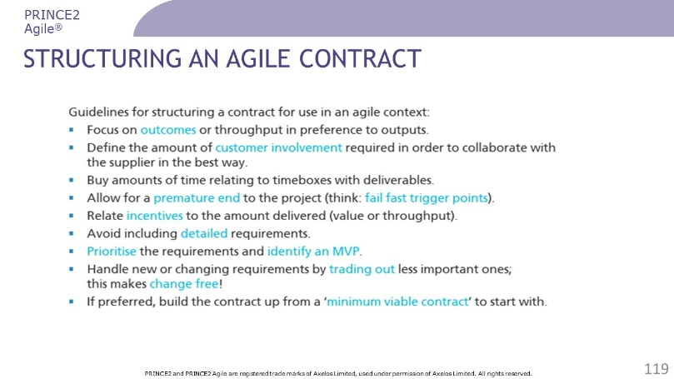 | ………………….………………………….………………  ……………………….……………….……………………  ………………………….……….…………………………  ………………….………….………………………………  …………………………………..…………………………  …………………………………..………………………………………………………..………………………………………..…………………………………..………………………………………..…………………………………..………………………………………..…………………………………..………………………………………..…………………………………..………………………………………..
Questions? | ………………….………………………….………………  ……………………….……………….……………………  ………………………….……….…………………………  ………………….………….………………………………  …………………………………..…………………………  …………………………………..………………………………………………………..………………………………………..…………………………………..………………………………………..…………………………………..………………………………………..…………………………………..………………………………………..…………………………………..………………………………………..

Review Questions – PRINCE2 Agile’s Focus Areas

1 | What is indicated if a slider score on the Agilometer is lower than its score on the previous assessment?  a) Less control or oversight of that area is needed  b) More Agilometer sliders should be monitored  c) Less agile techniques should be applied  d) More risk management of that area is needed
2 | Which of the following is a purpose of the rich communication focus area?  a) To replace documentation with verbal communication  b) To use as many communication channels as possible  c) To reduce the influence of dominant team members  d) To enable team members to work more effectively
3 | Which slider in the Agilometer would be MOST impacted by how closely the project's participants are located?  a) Flexibility on what is delivered  b) Ability to work iteratively and deliver incrementally  c) Ease of communication  d) Acceptance of agile
4 | Which BEST describes the purpose of the Agilometer focus area?  a) To tailor agile so that it can be used with PRINCE2  b) To help tailor PRINCE2 according to the agility of the environment  c) To assess how well a project is using the agile techniques  d) To assess which agile techniques are suitable for a project
5 | Which is NOT one of the five preparation steps to run a successful workshop?  a) Communicating outcomes  b) Logistics  c) Pre-reading  d) Attendees

Check your answers on page 56.

Answers to Review Questions
Page numbers are based on the 2015 edition of the PRINCE2 Agile manual.

Introducing PRINCE2
Q | A | Rationale
1 | D | ‘Tailor to suit the project environment, size, complexity, importance, capability and risk’ is a principle of PRINCE2.  Ref 5.2, tab 7.1
2 | D | The purpose of the change theme is to identify, assess and control any potential and approved changes to the baseline.  Refer to 5.1
3 | C | The purpose of the 'closing a project' process is to provide a fixed point at which acceptance for the project product is confirmed, and to recognize that objectives set out in the original project initiation documentation have been achieved (or approved changes to the objectives have been achieved), or that the project has nothing more to contribute.  Ref 22.1
4 | B | A work package is a set of information about one or more required products collated by the project manager to pass responsibility for work or delivery formally to a team manager or team member.  Ref A.26.1
5 | A | The project manager is responsible for the project producing a result capable of achieving the defined benefits.  The project manager’s prime responsibility is to ensure that the project produces the required products within the specified tolerances of time, cost, quality, scope, risk and benefits.  Ref tab B.1

Agile ways of working
Q | A | Rationale
1 | C | The product owner is accountable for effective product backlog management, which includes ordering product backlog items and ensuring that the product backlog is transparent, visible and understood.  Ref App H
2 | D | A burn-up chart has two lines, one increasing to show the amount of work completed, and the other showing the total amount of work to be done.  Ref 15.4.1.3, fig 15.1
3 | C | It is important to note that an MVP is about learning and may not go into operational use; it may be in the form of a simple experiment or prototype.  Ref 20.4.2.5
4 | B | A user story is 'ready' when it has a function that does NOT contain a solution.  Ref 25.6.1.7
5 | A | The term Minimum Viable Product (MVP) is associated with the Lean Startup framework.  Ref 20.4.2.5

Blending PRINCE2 and agile
Q | A | Rationale
1 | D | 'Self-organisation' creates mutual respect on the project.  Ref 7.4.4
2 | D | 'Exploration' uses learning to improve the products produced by the project, through iterative feedback loops.  Ref 7.4.5
3 | C | The 'embrace change' target allows for a more accurate final product.  Ref 6.4.3, tab 6.2
4 | B | Time tolerance is fixed at zero tolerance for extra time on all levels of plan.  Ref tab 6.1
5 | A | The 'be on time and hit deadlines' target allows the project to deliver early realisation of benefits.  Ref 6.4.1
6 | A | The 'keep teams stable' target allows for team members to change if necessary, as the needs of the project changes.  Ref 6.4.4, tab 6.2
7 | C | The 'accept that the customer doesn't need everything' target delivers what the customer really wants by prioritising these features.  Ref 6.4.5, tab 6.2
8 | C | The 'protect the level of quality' target leads to a lower cost of ownership throughout the lifetime of the product.  Ref 6.4.2, tab 6.1
9 | D | The supplier representative communicates guidance on areas of technical compliance, and provides support on releasing into operational use when needed.  Ref tab B.2
10 | B | PRINCE2 Agile is for any project, not just for IT projects. PRINCE2 Agile does not see working in an agile way as a binary condition (i.e. you either are or you are not working in an agile way). It always sees agile as a question of how much (or how little) it can be used according to the situation that exists.  Ref tab 3.4, 3.6

Tailoring PRINCE2 for agile
Q | A | Rationale
1 | D | The 'focus on products' principle flexes what is delivered to make it easier to stay in control of the project.  Ref tab 7.1
2 | D | The 'manage by exception' principle is at the heart of empowering people to self-organize and stay in control.  Ref tab 7.1
3 | C | One way to present a business case is to describe best-case and worst-case scenarios that relate to the number of features that are planned to be delivered. These scenarios can only be calculated when using high-level or (perhaps) intermediate-level requirements. It is unlikely that detailed requirements can be mapped directly to the business case.  Ref 9.3
4 | B | Both PRINCE2 and agile see change as inevitable.  Ref 14.3
5 | A | The frequent delivery of products that meet the appropriate acceptance criteria/quality criteria is the primary source of information with respect to progress.  Ref tab 8.1

PRINCE2 Agile’s focus areas
Q | A | Rationale
1 | D | Any deviation between the prediction and reality as perceived by the team would result in a change to the project management or delivery process. A slider that is much further left than predicted is likely to mean that an area of risk has been created, or that the situation has deteriorated since the last assessment.  Ref 24.5
2 | D | The purpose of the rich communications focus area is to help avoid many of the communication problems that can occur on a project, and explain the various ways in which information and knowledge can pass between project stakeholders in the most effective way.  Ref 26.1
3 | C | The environment is ‘communication rich’ with a lot of face-to-face interaction, and visual information is readily available in such forms as prototypes and models. Retrieval of information is also easy in order to reference knowledge, information or data that is either historical or current. An example behaviour is a high level of co-location.  Ref 24.7.3
4 | B | The purpose of the Agilometer focus area is to describe how to assess the agile environment in order to tailor PRINCE2 in the most effective way.  Ref 24.1
5 | A | A workshop should have five preparation steps: objective, attendees, agenda, logistics, pre-reading.  Ref 26.4.1

Document Location
The master softcopy of this document is held in //Courses/PRINCE2 Agile 2020/Foundation/P35_DELG.

Document Control
Copies of this document and any subsequent revisions shall be distributed electronically.
With the exception of controlled hard copies maintained by the Document Management Coordinator, paper copies of this document are deemed uncontrolled.

Revision History
Revision Date | Version | Author | Summary of changes
18Nov2021 | V01_00 | Geoff Rankins | First version
11Mar2022 | V01_01 | Geoff Rankins | Revised after Peoplecert review

Review
This document has been reviewed by:
Name | Title | Date of Issue | Version
Geoff Rankins | Lead Trainer | 11Mar2022 | V01_01
Peoplecert | Course Assessor | 11Mar2022 | V01_01

Approvals
This document requires the following approvals:
Name | Signature | Title | Version
Geoff Rankins |  | Lead Trainer | V01_01

Distribution
This document is required to be distributed to:
Role | Usage | Date of Issue | Version
Head Office | Master Copy |  | V01_01
Peoplecert | Escrow Copy |  | V01_01/PDF
Lead Trainer, Affiliates, Licencees | Working Copy |  | V01_01
Trainers, Printers | Field Copy |  | V01_01/PDF

